Centre for Tamil Culture

Aim and Purpose | AIM:  To nurture, preserve and propagate the rich Tamil tradition and culture and to make known to the outside world the great principles with which the ancient Tamils led a life of glory.  OBJECTIVES:  1. To guide the youth to understand the nuances of Tamil culture  2. To conduct research to find out the impact of Tamil language, culture and tradition on the  non-Tamil speaking people of other Indian States  3. To study the contribution of Tamil culture to the world  4. To establish a museum to showcase the collected artifacts, things and articles so as to  highlight intrinsic qualities and growth of Tamil life over the millennia  5. To conduct workshops and training programmes to teach the uniqueness of Tamil art,  culture and tradition.  6. To organize seminars, conferences and symposia to deliberate and assess the impact of  Tamil language and culture on the languages and cultures of the world.

Name | Designation & Dept./Division/College. | Status
Dr.S.Senthamizhpavai | Professor & Director  Centre for Tamil Culture  Alagappa University  Karaikudi | Coordinator
Dr.K.Kananathan | Assistant Professor  Centre for Tamil Culture  Alagappa University  Karaikudi | Member
Dr.V.Thiruveni | Assistant Professor  Centre for Tamil Culture  Alagappa University  Karaikudi | Member
Dr.M.Suganthi | Assistant Professor  College of Education  Alagappa University  Karaikudi | Member
Dr. S.Umadevi | UGC Assistant Professor  Dept. of Industrial Chemistry  Alagappa University  Karaikudi | Member
Dr. M.Mullai | Assistant Professor in Mathematics  Alagappa University  Karaikudi | Member
A.Sagunthala | Research scholar  Centre for Tamil Culture  Alagappa University  Karaikudi | Member
A. Vanithameri | M.A I Year  Department of History  Alagappa University  Karaikudi | Member

Activities Carried out
Year | Description of Activity | Date | Participants/  Beneficiaries
2016  2016 | Tamil Culture Katchiyagam  “ | 22.08.2016  29.09.2016 | Former Deputy Minister of Agriculture and Foreign Affairs, Government of Malaysia, T.R. Datho Shri Gokilam Pillai and his team  Beneficiaries - 30  Mr.S.V.Lingam visited Alagappa University Karaikudi on 29.9.2016. The team consisted of other distinguished personalities namely Mr.Arumugam, Mr.Alexander, Mr.Paneer Selvam. Mr.Thankaraj. Dr.Kokila Vanee. Mrs.Nilamarla, Mrs.Tanggamal. Mrs.Thavamani. Mr.Mahendran, Mr.Gunasekaharn, Mr.Kumaravelu. Mrs.R.Magisavery.Mrs.Chandrs and Ms.Santhanamary. Beneficiaries - 25
2016 | Special Lecture | 19.09.2016 | A special lecture programme on ‘Traditions and Ethical Principles of Society’ was conducted. 19.09.2016, Dr.S.Senthamizhpavai, Co-Ordinator Centre for Tamil Culture, welcomed the gathering. Prof.C.Sundaresan, Head of the Department, Centre for Folklore Studies, delivered a special lecture. Professors from Centre for Tamil Culture, research scholars, Ms.S.Chellam, Coordinator, Swami Vivekananda Centre for Higher Education and Research, Dr.M.Chidambaram, Dr.S.Naganathan Professors and students from Alagappa Government Arts College and Ramasamy Tamil College, participated in the function. At the end, Dr.K.Kananathan, Assistant Professor, Centre for Tamil Culture proposed a vote of thanks
2016 | Tamil Culture reawakening lecture programme | 20.09.2016 | Dr.A.Balu, the Principal, College of Education, Dr.M.Suganthi, a member of Centre for Tamil Culture Dr.S.Senthamizhpavai, Co-ordinator, Centre for Tamil Culture emphasized the importance of this Centre and also spoke about the contribution of the students. The other members of this Centre, Research Scholars, Professors from the College of Education, Alagappa University PG, UG students participated in this function. S.Umadevi, a member of the Centre for Tamil Culture, proposed a vote of thanks  Beneficiaries - Faculty, Scholars & Students - 200
2016 | Tamil Cultural Competition | 17.10.2016 | Competitions were conducted by the Centre for Tamil Culture for the post graduate students and affiliated college students on 17th October 2016, at the Centre itself. Winners were given cash prizes of Rs.1000/-, Rs.750 & Rs.500/-. And certificates were awarded to them in the conference held on 23.10.2016.  Beneficiaries - Students 100
2016 | International Seminar | 22.10.2016  23.10.2016 | Prof. Muhilai. Raja Pandian, Registrar, Central Institute of Classical Tamil, Chennai,  France, J. P Prasanth, Morae,  Dr.M. Krishnan, Associate Professor, Malaysian University, Dr.Shanthi Kesavan, Head, Dept. of Hindu Civilization, Eastern University, Sri Lanka, Prof A.Arivunambi, Pondicherry University, Prof. Aranga. Paari of Annamalai University,  Thavathiru. Ponnambala Adigalar, Prof.S.M. Ramasamy Former Vice - Chancellor, Gandhigram Rural University, Syndicate nember, Alagapp university France Sachichanantham  Beneficiaries - Faculty, Scholars & Students -300
2016 | National Seminar | 16.12.2016 | Kalaimamani T.R. Mahalingam’s daughter T.R M. Savitri Mahalakshmi Kalaimamani Dr.M.S.Sarala, Prof.Narayanamoorthy, Sydicate nember, Alagappa University Prof. N.Valli, Former Principal, Ramasamy Tamil College,  Beneficiaries - Faculty, Scholar s & Students -200
2016 | Tamil Culture reawakening lecture programme | 27.09.2016 | On September 27th, 2016, Tamil Culture was introduced to the students of Sri Saratha Women’s College. Mrs.Sivasankari, Asst. Professor from Tamil Department, Prof M.Meenalochani, the Vice-Principal of the college, Prof.S.Senthamizhpavai, Director, Alagappa University Centre for Tamil Culture,  Beneficiaries - Faculty & Students - 200
2016 |  | 28.09.2016 | The Head of the Department of Commerce, Dr.T.R.Gurumoorthy S.Senthamizhpavai, Co-ordinator, Centre for Tamil Culture  Beneficiaries - Faculty & Students - 75
2017 | Special Lecture | 27.02.2017 | Prof.S.Sentamizhpavai, Prof. Arivunambi, Subramania Bharathiyar Tamiliyar Pulam, Pondicherry University, Ms.S.Chellam, Co-ordinator, Centre for Swami Vivekanda Higher Research Education Dr. V. Thiruveni Assistant Professor, Centre for Tamil Culture, Alagappa University,  Beneficiaries - Faculty & Students -30
2017 | International Mother Language Day | 21.02.2017 | Dr.S.Senthamizhpavai, Director, Centre for Tamil Culture  Dr.K.Kananathan Dr.V.Thiruveni, Assistant Professor Centre for Tamil Culture, Mrs.S.Chellam, Swamy Vivegantha Centre for Higher Education and Research,  Tamil- N.Muthumani,  M.Shenbagavalli,  K.Kalaiselvi,  Malayalam- Srija,  Uruthu - Regina  Hindi - Geetha devi  French - Megarajbagam  Kinya- Ms.Agaththa (Ruvanda)  Beneficiaries - Faculty & Students -100
2017 | Workshop on Creativity of Students | 02.03.2017 | Prof.Aikkan, Formar Head of the Department in Tamil, Arumugam pillai Sethaiyammal College, Thirupathur, Kavigar. R.Kannathasan, Assistant Professor in Tamil, Sri Sevugan Annamalai College, Devakottai Prof.M.Chidhambarm, Associate Professor in Tamil, Alagappa Govt. College Karaikudi. Porkili, kavigar K.Nagappan, Karaikudi  Beneficiaries - Scholar & Students - 200

Tamil Culture Katchiyagam Visit -22.08.2016
T.R. Datho Shri Gokilam Pillai and his team
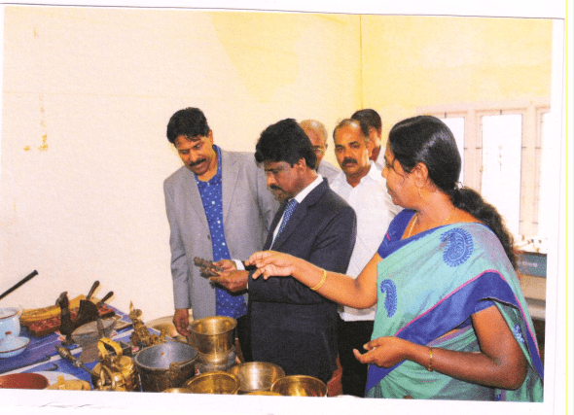
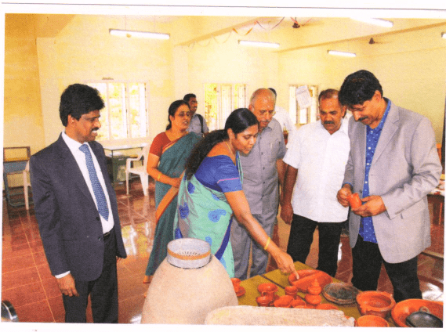

Mr.S.V.Lingam team visited - 23.08.2016

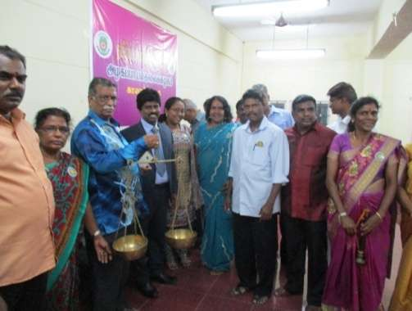
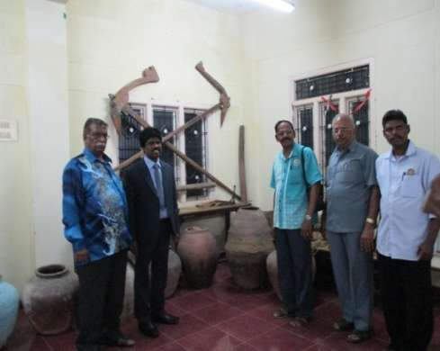

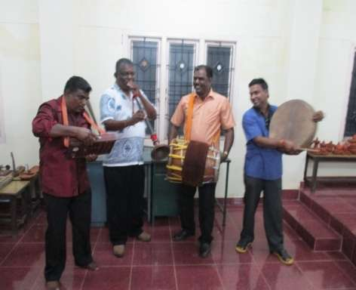

Special Lecture - Dr.C.Sundharasan -19.09.2016

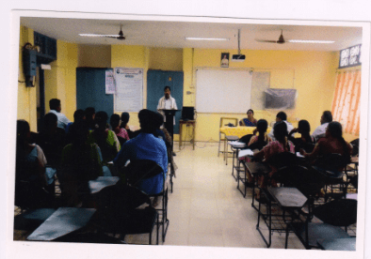
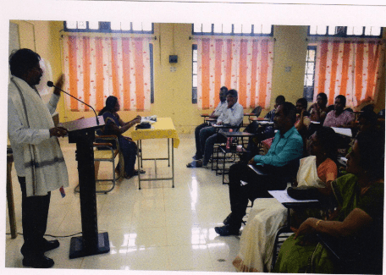

Tamil Culture reawakening lecture programme -20.09.2016

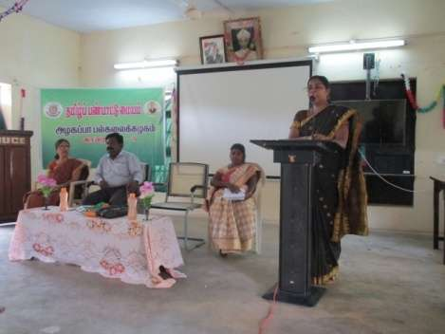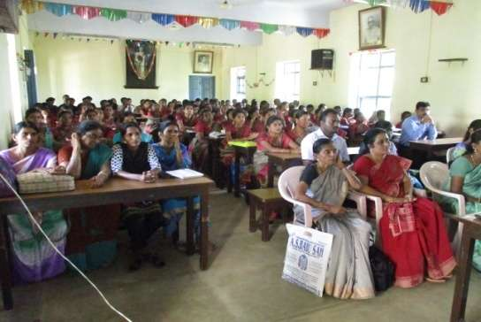

Tamil Culture reawakening lecture programme -21.09.2016

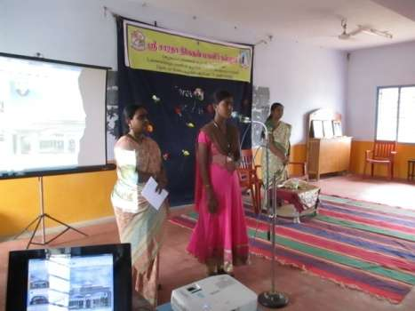
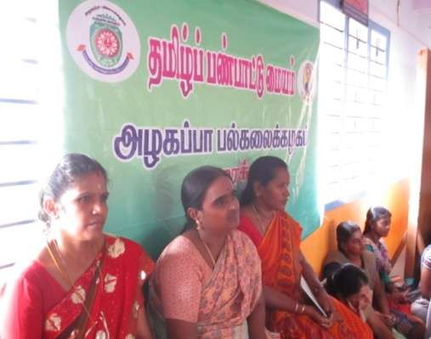
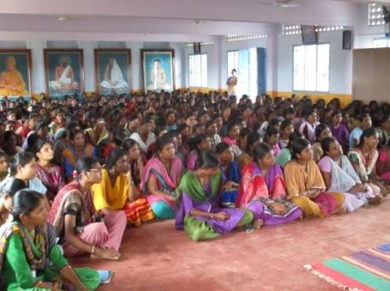

Tamil Culture reawakening lecture programme -28.09.2016

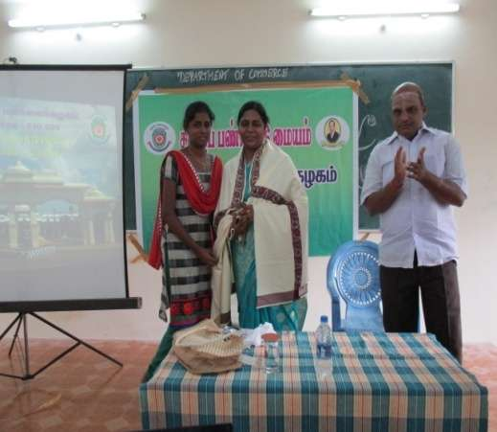
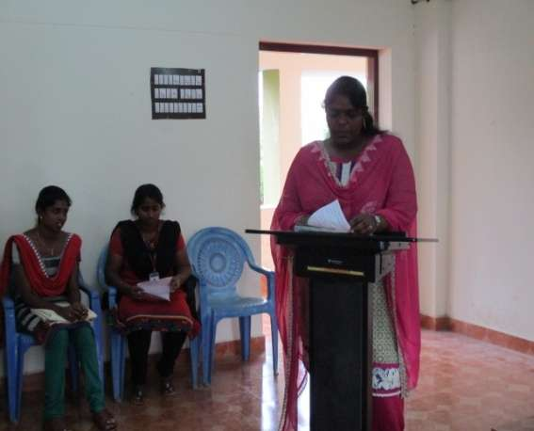
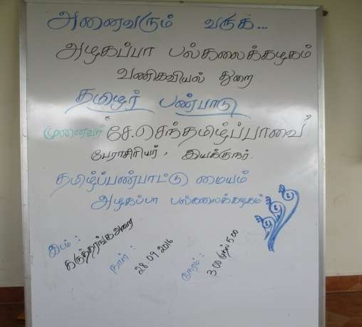
Tamil Cultural Competition - 17.10.2016

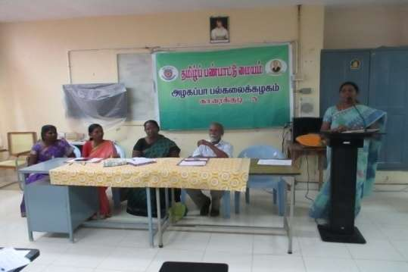
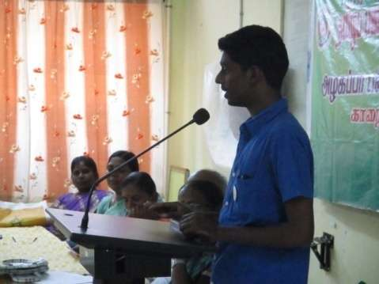
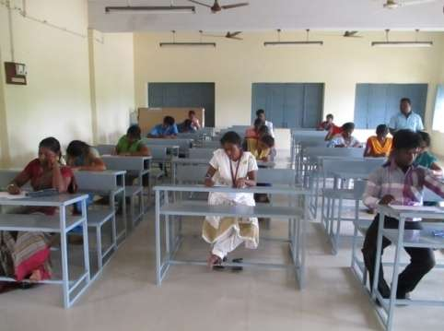
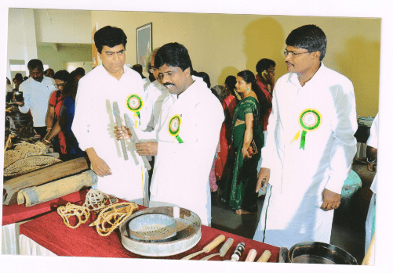
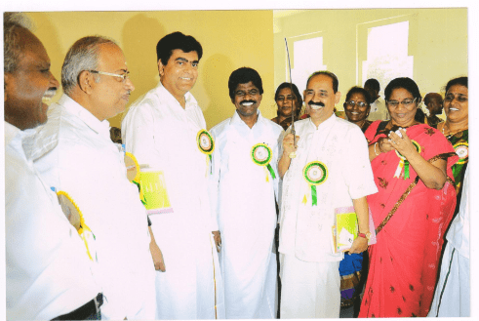
INternational Seminar - 21, 22.10.2016

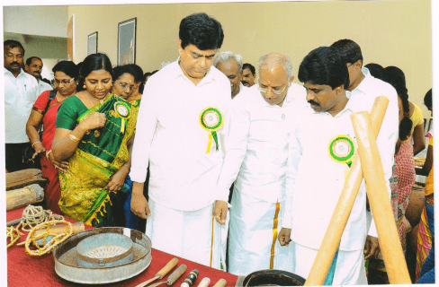

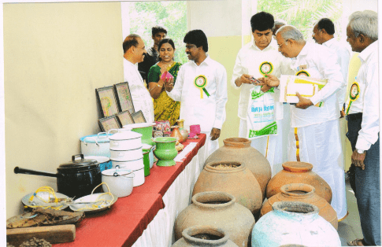

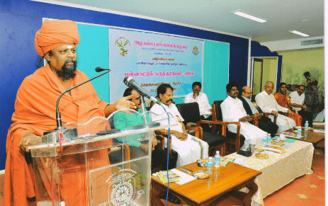
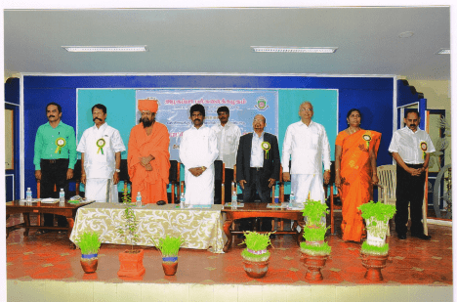

National Seminar - 22.10.2016

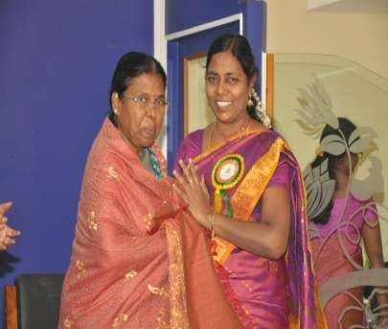
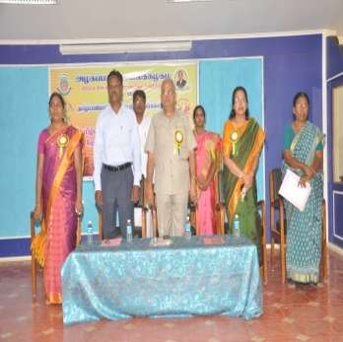
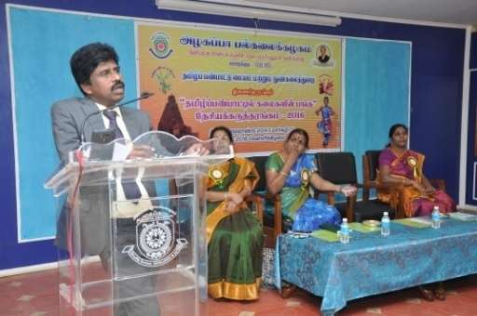

Special Lecture - Dr.A.Arivunambi -27.02.2017
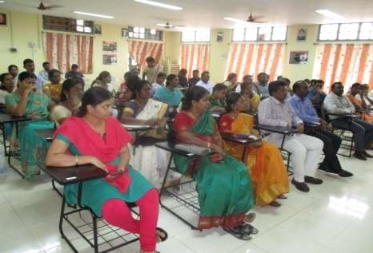
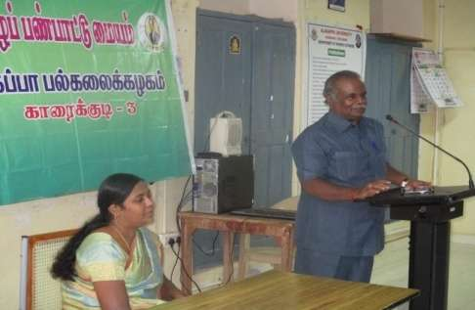

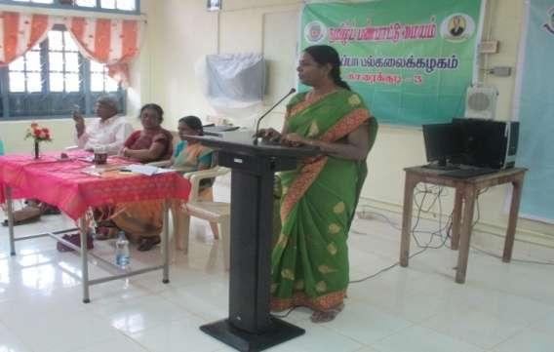
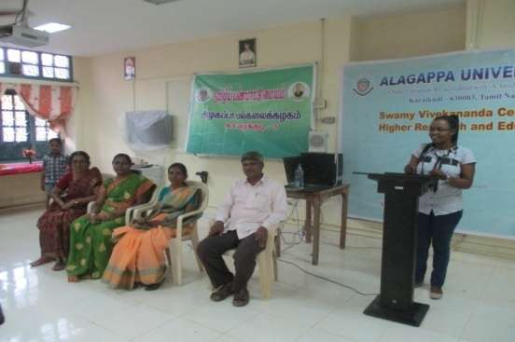
International Mother Language Day - 21.02.2017

Workshop - 02.03.2017

