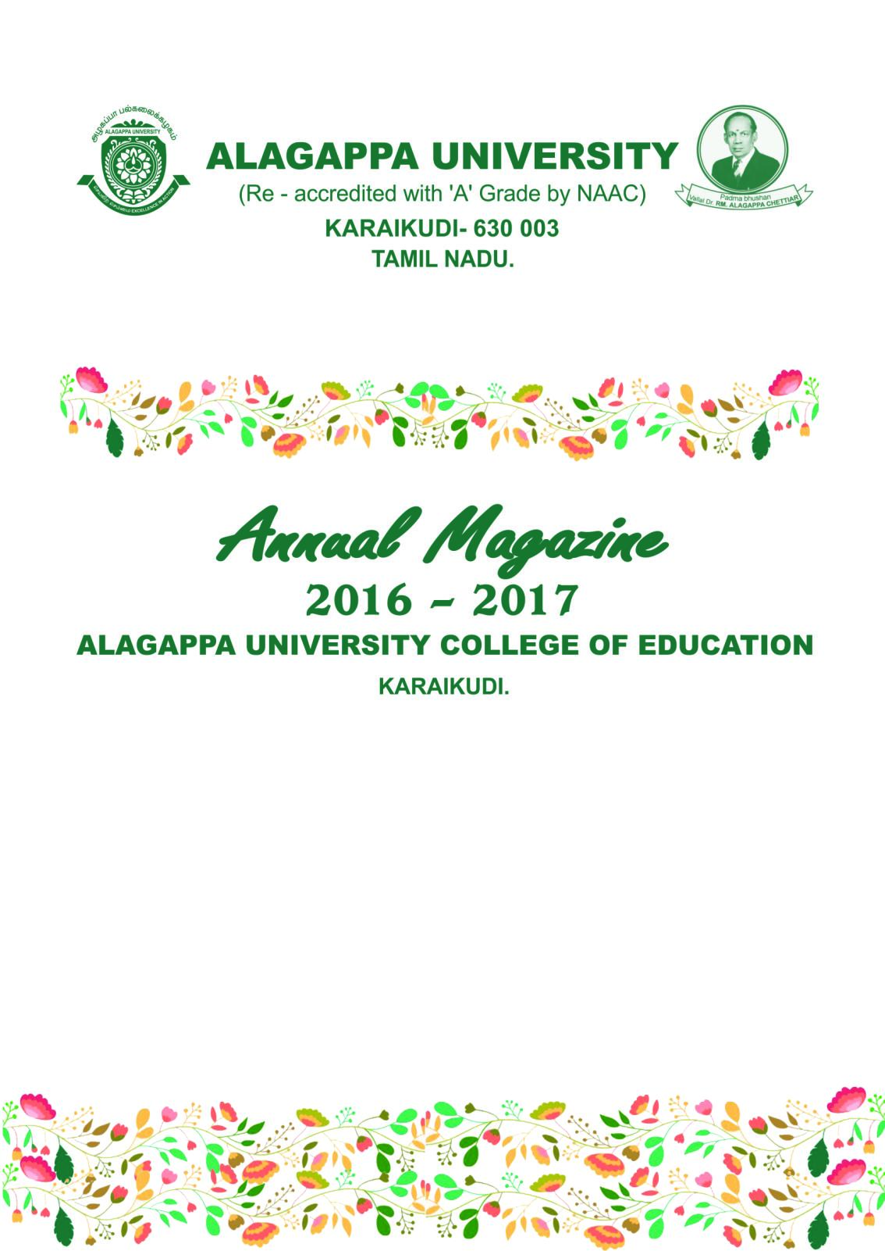

EDITORIAL BOARD

CHIEF EDITOR Dr. A. Balu. Principal.

Tamil Articles Dr. M. Suganthi

English Articles Mrs. V.Vidya

Drawing Mrs. E. M.N. Sharmila

TURNING THE PAGES
- FROM THE PRINCIPAL’S DESK
- TEACHER AND A PROFESSIONAL
- THE CORE TEACHING SKILLS
- MORAL VALUES- A CHALLENGE FOR A POSITIVE FUTURE
- A STEP INTO NEW ERA
- TEACH THE SEED TO BE A TREE
- FATHER OF PSYCHOLOGISTS
- FIVE LOVELY GEMS OF WISDOM
- FIVE THINGS YOU CAN'T RECOVER IN LIFE
- WOMEN'S ABILITY
- FAITH
- FRIEND’S LOVE
- WHO IS GREAT
- DO LESS
- SENTENCE CORRECTION TEST
- TAKE TIME TO RENEW YOUR MIND
- COLLEGE AIRLINES
- RIDDLES
- THERE ARE SEVEN SECRETS OF SUCCESS
- FUN TIME
- BEAUTIFUL THOUGHTS OF LIFE
- GOD
- SEVEN SACRED QUOTES
- WITH A LIGHT HEART
- MOTHER'S LOVE
- PUZZLES
- JOKES
- SCHOOL LIFE V/S COLLEGE LIFE
- PUZZLES
- AIMING HIGH
- SUCCESS
- PUZZLES
- COLLEGE LIFE
- WORD GAME
- PUZZLES
- LESSON FROM NATURE
- JOKES

nghUslf;fk;
- ngQ;rkpd; gpuhq;f;spdpd; Kd;Ndw;wj;jpw;Fj; Njitahd 13 ew;Fzq;fs;
- kfhftp ghujpapd; nghd;nkhopfs;
- vOr;rp nfhs;
- Mrpupar; #upad;
- kwf;fg;gl;l jkpo;
- mofg;gh gy;fiyf;fofj;jpd; ntw;wpg; ghij!!
- vk; kz; ePNa! fy;tpapy; fy;YhhpjhNa
- ngz; tpLjiy
- Mrphpah;
- md;id
- el;G
- ek;gpf;if
- mk;kh
- MrpupaH
- kio
- tho;f;ifapd; ,ufrpak;
- fhdy; ePH
- kwthNj
- flik
- tho;f;iff; fzpjk;
- tplhKaw;rp
- ngz;ikapd; rpwg;G
- jkpoupd; gz;ghL
- gl;ljhup
- JzpT
- fhfpjk;
- ,aw;if
- ,isQNd!
- jd;dk;gpf;if
- jkpo;
- fhisapd; rpwg;G
- ngz;ik
- ,aw;if
- mk;kh
- vjpHghHg;G
- vJTNk Kbatpy;iy...
- fw;Wf;nfhs;!
- i`f;$...!
- kyupd; jj;Jtk;
- MrpupaHfisg; Nghw;WNthk;…
- KJikapd; typ…!
- ,isQd; vOr;rp…!!!
- VTfiz ehafd; fyhk;
- Nehgy; gupR
- mk;kh…!!!
- tha;g;G
- ntw;wp
- mk;kh…!!!
- ghJfhg;G
- jhapd; fUtiw…
- ,ize;jhy; ,ayhjnjhd;Wkpy;iy!
- mk;kh…!
- ed;wp nfl;l cyfk;
- mlNl…!!!
- mOjhYk; fz;zPH tuhJ!
- jkpo; nkhop capupd; rpwg;G
- mwd; typAWj;jy;
- jha; cs;sk;
- Nghijg;gof;fk;
- ntw;wpapd; mbf;fy;
- mk;khtpw;F XH jhyhl;L
- nkd;ikAk; tPuKk;
From the Principal’s Desk ……
Living by example is the best way to inspire others. M.K. Gandhi rightly said, “Be the change that you want to see in the world.” It is only by becoming the messenger as well as being the message, your role as a model becomes effective.
When you live to make a difference in the life of others, your life focuses on intentional living. It is only by being conscious of your purpose in life you can set an example to the people who look up to you.
All of us are geniuses, endowed with different talents. The first step to discover our geniuses is to let go of our negative self-images. The second step is to discover where our genius lies. We are not good at everything. Thus, it is important to find out where we are capable of excelling in. The third step is making use of our talents. It is said that geniuses are not born but made. It is only by determined efforts in spite of difficulties we prove ourselves geniuses in what we do.
Then, why not discover the genius in you and make a breakthrough in life? Let us all set grand examples for the coming generations!
Dr. A. Balu.
Principal.

TEACHER AND A PROFESSIONAL TEACHER
An over view
Teaching is not just telling. It is communicating. The information bits given by the teacher should be understood in the sense it was intended. If there is misinformation or no decoding of the receiving end, information gaps are created. A resourceful teacher can make his teaching effective by his sense of humour, use of appropriate -illustration, involving students in practical work, use of language appropriate to the class .Effective teaching includes is variety of competencies. Teaching is a profession of initiating people into profession. In this specialised job of communication the 'Hard component ' of content mastery and the soft component of pedagogy is essential. In one sense, teacher is the real " maker of history and man". This teaching is the largest of all professions:. and the mother of professions. How-ever, the social status of the teacher and the history of teaching profession are not in straight lines but with certain variations and facilities by the time and need. The professional values of teaching and teacher life, acquisition, transmission and additional new knowledge, cultivation of excellence social responsibility etc. are changing according to the rhythm of the society.
The success of the educational system is dependent more on teachers than on other facilities. At present we do not have sufficient number of happy, satisfied, enthusiastic and properly trained teachers. The teacher is the noblest symbol of the nations culture and civilisation and teaching is the a glourious and glittering effort for the good continuity and noble changes of the dynamic societies. Teaching is not a class room interaction only but providing a leadership grole in the learning community in which both teachers as well as students are members. In other words, a person with an attitude of reconciliation, sacrifice and service can be a good teacher. This lead to the professionalization of today. This is the main reason for the immortality of world renowned teachers like, "Rishis, Dudha Jesus Christ, prophet Muhammed, Adi Sankara, Vivekananda etc. In this connection we can assure that the teacher is the man who speaks the most important role in bringing out the best out of an individual and give him right type or personality. It carries professionalism and teaching should not be reduced to trade. What does teaching mean ? Teaching is providing instruction or guidance. When you give him a pieces of knowledge instruct him about something, impart some skill or make him wise about an object or thing. You are teaching him. How ever in popular mind teaching is associated with classroom instructions. Now most of our society consider teaching us profession. A profession is the occupation if not purely mechanical, agricultural or the like to which one devoting himself, a calling in which one professes to have acquired some special knowledge used by way either of instructing, guiding or advising others or serving them some art as a profession of aiming of teaching of Chemist. Broadly speaking one principal celling, Vocation or employment (webster's definition). The principle of code and conduct is including the professional characteristic of teaching. Moreover, the members of a profession requires command of a theoretical body of knowledge. Teachers have certain duties for reorganizing the heterogenous aspects of the dynamic society. In short, professionalism is, in but an ideology of control. The professional teacher must have basic knowledge of the culture of the society and must have attained considerable maturity in the habits of work and philosophy of life. This professional status or the teaching is that industrial revolution brought a new concept of teacher profession. Hence, the modern concept of the mobility of the teaching profession is not the legacy of the past. The Kothari Commission (1964-66) emphasised that interview and continuous efforts were necessary to -- the economic, social and professional status of teachers, along with accepting and introducing new teachers, along with, accepting and introducing new methods for improving the self request and qualities of the teachers. It is true that, no programme and education can succeed with out suitable teacher who will be above casteism, communalism, parochialism and all other narrow loyalties. Through education Dr.S.Radhakrishnan wants to establish a classless society in order to bring equality between man and man. That the teaching profession occupies high position and becomes glorious. In short, teaching is not to attain a glorious and bright future. Here the important professionalism of teaching is existing. For this the teacher should be an idealist, naturalist, realist and pragmatist. He should be able to influence his student through his behavior and conduct more outside the class room then through his teaching in the class room. For achieving complete professionalism -teachers must also be learning. A lamp can never light another lamp unless it continues of burn own flame" (Tagore) and because " a teacher can newer, truly teach unless he is still learning him-self". Strong unified and responsible teachers associations are also necessary for the protection of the dignity and rights of teaching and also for ensuring proper professional conduct of teachers. The National Policy on Education (1986) envisages the involvement of teachers association in upholding the dignity of teacher as well as in curbing their professional misconduct and establishing sanctity of teaching.
Dr.J.E. Merlin Sasikala
Assistant Professor.

THE CORE TEACHING SKILLS CAN BE FROM METACOGNITIVE INTERVENTION STRATEGY TRAINING AS DETAILED BELOW:
- accelerated learning/study skills
- accelerating and evalution
- answer first
- behaviours
- behaviour management
- best practice
- breakouts
- copying
- curriculum developement
- decoding
- delaying negative response
- direct instructions
- educational literacy
- effective rewards
- excuse
- interventions
- involvement
- learning style & intelligence
- mastery
- memory maps
- note taking
- positive discipline
- precision teaching
- prompts
- proximity management
- questions
- reading aloud
- reading mastery
- reinforcement
- repeat until firm
- research
- response
- rewards
- scripts
- self correction
- show you are ready
- signaling
- skill leve/ability/groups
- solution key
- student orientation
- teaching by objective
- teaching by mastery
- tell backs
- testing the learning
- theory of instruction
- voice of eyes
- quality
To learn these skills all participants begin by mastering . With the mastery of this basic skill set , any subject can be effectively taught virtually to all students regardless of learning style and special learning challenges.

Dr. Parimala Fathima,
Assistant Professor.
Nghuhl;lk;
typNahL Nghbdhy; jhd;
xU ngz; jhahf KbAk;
,UNshL Nghuhbdhy; jhd;
GO tz;zj;Jg;g+r;rpahf KbAk;
kz;NzhL Nghuhbdhy; jhd;
tpij kukhf KbAk;
tho;f;ifNahL Nghuhbdhy; jhd;
eP tuyhW gilf;f KbAk;.

Dr.M. Suganthi
Assistant Professor

Moral Values- A Challenge for a Positive Future

According to Father of Indian Nation M.K.Gandhi,
"If wealth is lost nothing is lost"
"If health is lost something is lost"
"If character is lost everything is lost"
Best of all things is character.
Everyone knows that life is precious – that life is important. We all protect our life because we care for it more than anything else. If life is so important, the values of life are even more important. Values are guiding principles, or standards of behaviour which are regarded desirable, important and held in high esteem by a particular society in which a person lives.
A famous Chinese proverb says that
"If there is righteousness in the heart, there will be beauty in character,
if there is beauty in character, there will be harmony in the home,
when there is harmony in the home, there will be order in the nation,
when there is order in the nation there will be peace in the world".
Mere academic knowledge is not sufficient; character building should be a vital component of education. The importance of life should not be taught, but should be trained. We want to have the training through which we develop the feelings of Nationalism and cultivate moral values in our lives. Besides Education, we should be deeply involved in such works through which we develop feelings of love and brother-hood. It is the responsibility of the parents and teachers to make future builders of the Nation.

"Education without values, as useful as it is, seems rather to make man a more clever devil. " - C. S. Lewis
Education is necessarily a process of inculcating values to equip the learner lead a life – a kind of life that is satisfying to the individual in accordance with the cherished values and ideals of the society. But today Education has become just a nine letter word as a superior term in the dictionary. Moreover Education system became a business where it is treated like any other profession. The problem is also with us. It is we who make the society. If we improve ourselves, we can improve our society. No one is a born a criminal or a spoilt person. It’s the environment that is deviating the child way from taking the right path. Good teachers can bring the change with good Education imparted to the students. Education is the combination of literacy and morale values. We can’t get good quality of Education if they were to be seen in isolation.
Therefore, philosophers, spiritual leaders and educationists of our country, all in various ways, have emphasized the role of education for ‘character development’, ‘bringing out the latent potentialities and inherent qualities’ and developing an ‘integrated personality’ for the well being of the individual and the society at large. Then our Country will become a dream land and a dream destination.
Dr.A. Pio Albina,
Asst. Prof. in Mathematics,
E-mail : pioalbina123@gmail.com

A Step into New Era
We never thought that 8th November 2016 would become an unforgettable day. The government announced demonetization -the decision to discontinue the legal tender status of Rs 500 and Rs1000 notes.
We shall see a great impact of this move of the Central Govt on Indian Society and Economy. The first impact shall be that people will have lower expenditure power. With that, they will not be able to purchase luxurious things. So the society will grow lesser materialistic and people more prudent. With the fake money destroyed, Indian economy will see a big boom. It will surely bring the clear view of every transaction within the country and promote cashless transactions. This step will affect general people to some extent but for the benefit of the future generation, such decisions are inevitable. We should welcome such brave step of Indian government which will curb black money to some extent.
The banking system will improve as it will slowly head towards a cashless society, which will increase credit access and financial inclusion. The existing white money of people will be known to the government and it will remain with banks so that it can be put on loan, and interest can be generated from it with a corresponding fall in Inflation.
The things shall be cheaper. Indian Currency shall get respect at the international market. There shall be a great check on the terror-related funding and therefore on terrorist activities. Corruption shall be down to a great extent as people will stop the tendency of accumulating money using wrong means. It will bridge the gap between the haves and the have-nots. However, there may be some difficulties. But this inconvenience shall be temporary and for short-term.
Hoping that each and every one of us is going to reap the fruits of demonetization, let us render the support to develop and clean India.

Dr. J.Jayachithra

Asst. Professor of Education
email: jayamadhav.chithra@gmail.com

Teach the Seed to be a Tree

“Institutions build professionals
Parents develop the person”
Parents are the primary architects in the development of character in children. Many personalities such as Sachin Tendulkar used to say-
“My father always told me….
My brother used to tell me…”
Jawaharlal Nehru said to Indira Gandhi-
“You will often find your life splitting into two roads- one, the easy and crowded and the other, the tough and less crowded. Take the less crowded and that will make all the difference.”
Indira Gandhi acknowledged – “That is exactly what I did and that has made all the difference.”
Parents are like scriptures to their children-Quran, Gita and Bible-they read in their lifetime and Dharma –they will follow.
It is the responsibility of parents and teachers to create avenues to develop multiple intelligence and enable the child to be a unique personality and capable of being spotted in a crowd.
Each child is a rare, unique master piece…………..MASTER PIECE.
Don’t try to mould them into a SHOWPIECE. Parents and Teachers should preserve the originality of the child.
“It is easy to be one in the crowd. It needs courage to be different from the crowd”.
Children are basically god’s creation entrusted in the hands of parents and teachers with the trust that they will play their part.
So, “Teach the seed to be a Tree”.
Dr.G.RAJESWARI
Assistant Professor.

FATHER OF PSYCHOLOGISTS
- SIGMUND FREUD (1856 - 1939) - Father of psychoanalysis & Modern psychology.
- HUGO MUNSFERBERG (1863 -1916 ) -Father of Applied psychology (GERMAN - AMERICAN PSYCHOLOGIST )
- JOHN BOWLBY - Father of Attachment theory (1907 -1990 ) (BRITISH PSYCHOLOGIST)
- KURT LEWIN - (1890 -1947 ) Father of social psychology (GERMAN - AMERICAN Psychologist )
- JEAN PIAGET (1896 -1980) - Father of Developmental Psychology (Swiss clinical psychology )
- LIGHTNER WITMER (1867 - 1956 ) - Father of modern clinical psychology (AMERICAN PSYCHOLOGIST )
- GORDEN ALLPORT - Father of personality psychology (AMERICAN PSYCHOLOGIST ) (1897 -1967 )
- WILHELM WUNDT (1832 - 1920 ) - Father of Experimental psychology &Father of modern psychology ( GERMAN PSYCHOLOGIST )
- MARTIN SELIGMAN (1942 ) -Father of positive psychology (AMERICAN PSYCHOLOGIST)
- EDWARD THERDIKE -Father of modern educational psychology (AMERICAN PSYCHOLOGIST
- ULRIC (DICK ) NEISSER -Father of cognitive psychology.
M.SHANMUGA REVATHY
Assistant Professor.
**************

Five Lovely Gems of Wisdom
- There is a thorn in every alluring rose.
- Under great pressure and extreme temperature, a coal is transformed into a dazzling diamond.
- When an oyster is being irritated by a grain of sand, a precious pearl is formed.
- From an ugly caterpillar, a beautiful butterfly is born.
- After a storm, you can behold the radiance of a shimmering rainbow.

V.Vidya
Teaching Assistant.
FIVE THINGS YOU CAN'T RECOVER IN LIFE
- A stone after it’s thrown.
- A word after it’s said .
- An occasion after it’s missed.
- Time after it’s gone.
- Trust after it’s lost.
- A .ANBARASEN
****************************************************
WOMEN'S ABILITY
"If you want something, ask a man.
If you want something done ask a woman."
"Women are agents of change ,
We are drivers of a progress ,
We are makers of peace ...... All
We create a world without "HARRASSMENT".
- A .ANBARASEN
FAITH
The source of faith is God.
The centre of faith is Sacrifice.
The power of faith is Prayer .
The seed of faith is Sincerity.
The harvest of faith is Happiness.
The secret of faith is Friendship.
The joy of faith is Sharing.
The beauty of faith is Growth.
The result of faith is Service.
The wisdom of faith is Patience.
The sound of faith is Harmony.
The bliss of faith is Tranquility.
M . SIVAYOGA BHARATHI
**********************************************************************************
FRIEND'S LOVE
"Chamomilla " is beautiful
Like my friend’s face .
"Marjoram " smells sweet
Like my friend’s words.
"Sunflower' looks cheerful
Like my friend’s smile .
" Shoe flower" poses pretty
Like my friend’s love.
The beauty of flowers may go dry
But my friend’s love will never die.
M . SIVAYOGA BHARATHI

WHO IS GREAT
He is not great
Who is proud of his wealth.
But he is great
Who says 'it is god's wealth.
He is not great
Who says ,'I am the owner'.
But he is great
Who says , I am a trustee'.
He is not great
Who is proud of his knowledge.
But he is great
Who feels that he is ignorant .
He is not great
Who is proud of his strength.
But he is great
Who protects the weak and innocent.
V .VINI THA
**********************************************************
DO LESS
Do less thinking
And pay more attention to your heart.
Do less acquiring
And pay more attention to what you already have.
Do less complaining
And pay more attention to giving.
Do less controlling
And pay more attention to letting go.
Do less criticizing
And pay more attention to complementing.
Do less arguing
And pay more attention to forgiveness.
Do less running around
And pay more attention to stillness.
Do less talking
And pay more attention to silence.
M .GAYATHRI
*****************************************************
SENTENCE CORRECTION TEST

- Many middle class individuals find that they cannot obtain good medical attention therefore they need it badly.
(A) Many middle class individuals find that they cannot obtain good medical attention, despite they needing it badly .
( B) Many middle class individuals find that they cannot obtain good medical attention, despite their needing it badly .
(C) Many middle class individuals find that they cannot obtain good medical attention, in spite of they need it badly .

(2) He enjoys neither speaking in public nor for teach.
(A) He enjoys neither speaking in public nor teaching .
(B) He neither enjoys speaking in public nor to teach .
(C) He enjoy neither speaking in public nor teaching.

(3) William dislikes them continual smoking .
(A) William dislikes them they're continuous smoking .
(B) William dislikes their continual smoking.
(C) William dislikes their continuous smoking.

(4) Reaching into the hat, a group of rabbit was pulled out by the magician .
(A) Reaching into the hat , a group of rabbit was pulled out by the magician .
(B) Reaching into the hat , groups of rabbit are pulled out by the magician .
(C) Reaching into the hat , the magician pulled out a group of rabbits .
(5) To be able to graduate, you must first complete you're senior year .
(A) To be able to graduate , you must first complete your senior years .
( B) To be able to graduate, you must first complete you're senior years .
(c) To be able to graduate, your senior year must first be completed .
TEST ONE ANSWER KEY
QUESTION 1 2 3 4 5
ANSWER B A B C A
M. SINDHU

TAKE TIME TO RENEW YOUR MIND
Take time to pray ....
It is the greatest power on earth .
Take time to think ....
It is the source of power ....
Take time to work ....
It is the price of success.
Take time to read ....
It is the foundation of wisdom .
Take time to play ....
It is the source of energy .
Take time to laugh ....
It is the music of the soul .
Take time to be friendly ....
It is the road of happiness .
- S.K SHYAMALA DEVI
**************************************************** COLLEGE AIRLINES
Pilot – Vice-chancellor
Co - pilot - Principal
Crew - Male teachers
Air -Hostesses - Female teachers
Passengers - Students
Ground Engineer - Office - staff
Take off - 10.00 a.m.
Landing - 5.00 p.m.
Service - On all working days
Fare - Low fees
Control-room - College Management
Classes - B.Ed & M.Ed
Baggage - College bag
Flight - Alagappa University
Final call for boarding - Bell
Information - Dial college phone number .
V. SUBHASHINI
******************************************************
RIDDLES
1. On what kind of ships do students study ?
2. What always comes into a house through the key hole ?
3. What goes around the world but yet stays in one corner ?
4. Which animal is on legal documents ?
ANSWER
1. Scholarship
2. Key
3. A stamp
4. Seals

V. SUBHASHINI

THERE ARE SEVEN SECRETS OF SUCCESS
"Lying in your room itself "
Roof says : Aim High.
Fan says : Be cool.
Clock says : Every second is precious.
Mirror says : Reflect before action.
Window says : See the world.
Calendar says : Be updated.
Door says : Push hard to achieve your goal !!!
- SUBHA . R
******************************************************
FUN TIME
Teacher : Name the liquid which changes to solid when heated.
Student : Idly
Teacher : What is the name of Gandhiji 's son ?
Teacher : Why ???
Student : Mahatma Gandhi is the father of di - neshan.
- SUBHA . R
*****************************************************

BEAUTIFUL THOUGHTS OF LIFE
The adventure of life is to LEARN.
The purpose of life is to GROW.
The nature of life is to CHANGE.
The challenge of life is to OVERCOME.
The essence of life is to CARE.
The opportunity of life is to SERVE.
The beauty of life is to GIVE.
- SUBHA . R
****************************************************
GOD
Happy moments,
Praise God.
Difficult moments,
Seek God.
Quiet moments,
Worship God.
Painful moments,
Trust God.
Every moment,
Thank God.
- SUBHA . R
******************************************************
SEVEN SACRED QUOTES
LOVE YOUR ENEMY
Hinduism:
A noble soul will ever exercise compassion even towards those who enjoy injuring others or those of cruel deeds when they are actually committing them - for who is without fault? ( Ramayana , Yudha 115).
Christianity :
Love your enemies and pray for those who persecute you. If you love those who love you, what reward will you get ?
( Mathew 5: 44, 46).
Islam:
Repel the evil deed with one which is better, then he between whom and you there was enmity shall become as though he were a bosom friend ( Quran 41.34).
Judaism :
Aid an enemy before you aid a friend, to subdue.
(Tosefta, Baba Metzia 2.26).
Buddhism:
Hatreds never cease through hatred in this world ; through love alone they cease . This is an eternal law ( Dhammapada 3-5).
Jainism :
Man should subvert anger by forgiveness, subdue pride by modesty , and overcome hypocrisy with simplicity, and greed by contentment (Samanasuttam 136).
Confucianism:
Confucius said , " He whose heart is in the smallest degree set upon Goodness will dislike no one " . ( Analects 4,3.4).
- JEEVASUDHA . K
*****************************************************
WITH A LIGHT HEART
Patient : It must be tough spending all day with your hands in someone's mouth.
Dentist : I just think of it as having my hands in their wallet.

A man takes his son tiger-hunting. They are creeping through the weeds and the man says, "Son, this hunt marks your passage into manhood. Do you have any questions? " And the boy says, "Yes, If the tiger kills you, how do I get home?
MOTHER'S LOVE
Land can have an end,
Sky can have an end,
Sea can have an end,
Even end can have an end
But, Mother love can never end.
- Gohilavani.c
************************************************************************

PUZZLES
1. ABCDEFGH
What letter comes three to the right of the letter that comes immediately to the left of the letter that comes three to the right of the letter immediately to the left of the letter B ?
Answer :
"F"
2. AZBYDWGT??
What two letters come next?
Answer : K and P
Solution :
There are two alternate sequences. Starting at A, ABCDEFGHIJK; Starting at Z, ZYXWVUTSRQP.

3.Using the five letters below, create a nine-letter word.
"LOPER"
Answer :
PROPELLER
- Gohilavani.c

JOKES
Teacher : Who are the most devote people?
Student : Thief sir!
Teacher : Why?
Student : They spend more time in temples nowadays to steal the valuables there.
Peter : Daddy, I got a hundred marks in school today!
Father: That's wonderful! For what did you get a hundred in?
Peter : 30 marks for Maths, 50 marks for English and 20 marks for science.
Altogether 100 marks.
- Gohilavani.c
SCHOOL LIFE V/S COLLEGE LIFE
1. School - One pair dress for 7 days.
College - 7 pair dress for one day.
2. School - 2 notebooks for one subject.
College - 1 notebook for all subjects.
3. School - A white pipe in teacher's hand (chalk).
College - A white pipe in student's hand (cigarette).
4. School - Most frequent letter: leave letter.
College - Most frequent letter: love letter.
LAVANYA.C
PUZZLES
1. You throw away the outside and cook the inside. Then you eat the outside and throw away the inside. What did you eat?
Answer : An ear of corn.
2. A woman shoots her husband. Then she holds him under water for over five minutes. Finally, she hangs him. But five minutes later, they both go out together and enjoy a wonderful dinner together. How can this be?
Answer : The woman was a photographer. She shot a picture of her husband, developed it, and hung it up to dry.
3. A Queen bee was buzzing, a worker bee was buzzing, a honey bee was buzzing, and a killer bee was buzzing. How many bees were in buzzing?
Answer : One. There is only one "b" in the word buzzing.
4. It you are eight feet away from a door and with each move you advance half the distance to the door. How many moves will it take to reach the door?
Answer : You will never reach the door; it will always be half the distance, no matter how small.
- MAHESWARI.A
********************************************************
AIMING HIGH
Aim high,
It must arise in your mind.
Tragedy of life doesn't lie in not reaching your goal,
Tragedy lies in having no goals to reach.
It's not a calamity to die with dreams unfulfilled,
It's calamity not to dream.
It's not a disaster to be unable to capture your ideas,
It's a disaster to have no ideas to capture.

It's not a disgrace not to reach the wonders,
But it's a disgrace to have no wonders to reach.
- MAHESWARI.A
********************************************************
SUCCESS
Sincere efforts
Will surely be rewarded!
For every
Confident step
We should go against
Our failure.
Then success would come
One step towards us!
A Kite flying
In air is due to luck.
But a bird flying
In air is by its effort.
So be a bird and
Struggle with hurdles to
Become a successful person.
Mistakes increase your
Experience and experience
Decreases your mistakes.
Learn from your mistakes
Then others will learn
From your success.
- KEERTHIGA.K
**********************************************************
PUZZLES
1. There were six apples in a basket and six girls in the room. Each girl took an apple. Yet one apple remained in the basket now?
Answer : The first five girls took an apple each. The sixth girl took the basket as well as the apple in it.
2. A man who was not wearing a parachute jumped out of a plane. He landed on hard ground yet he was unhurt why?
Answer: The plane was parked on the way.
- KEERTHIGA.K
COLLEGE LIFE
So many hands in one Tiffin box.
So many friends in one bench.
So many calls on birthday night.
So many messages on festival days.
So many tears for one little fight.
So many memories in one little heart.
Enjoy life to the fullest with all your
Friends with little tears and great smiles.
- ARCHANA.M
______________________________________________________
WORD GAME
The most selfish one-letter word - "I"
- Avoid it.
The most satisfying two-letter word - "WE"
- USE IT.
The most poisonous three-letter - “EGO”
- KILL IT.
The most used four-letter word - "LOVE"
- VALUE IT.

The most pleasing five-letter word - "SMILE"
- KEEP IT.
The fastest spreading six-letter word - "RUMOUR"
- IGNORE IT.
The most working seven-letter word - “SUCCESS "
- ACHIEVE IT.
The most enviable eight-letter word - "JEALOUSY"
- DISTANCE IT.
The most powerful nine-letter word - "KNOWLEDGE"
- ACQUIRE IT.
The most divine ten-letter word - "FRIENDSHIP"
- MAINTAIN IT.
- ARCHANA.M
***************************************************
PUZZLES
- Complete the given word on the left and start another word on the right - RAM (....) RIDGE?
- Work from square to adjacent square horizontally or vertically (but not diagonally) to spell out a 12 letter word. You must find the starting point and prove the missing letters?

ANSWERS:
1. PART (Ram part and Partridge).
2.Professional.
RENUKA.R
********************************************************
LESSON FROM NATURE
I learnt from the sun
To spread Light.
I learnt from the breeze
To be cool all the time.
I learnt from the trees
To be colossal in giving.
I learnt from water
To be serene.
I learnt from earth
how to nurture the very who people trampled it.
I learnt from the fire
To be pure and to purify.
I learnt from the space
The virtue of being big.
- M.SARANYA
**********************************************************
JOKES
GIRL: You would be a good dancer except for two things.
BOY: What are the two things?
GIRL: Your feet.
@@@@@@@@@@

PATIENT: Doctor, I have pain in my eye whenever I drink tea.
DOCTOR: Take the spoon out of the mug before you drink.
@@@@@@@@@@@@
TEACHER: Tell me a sentence that starts with an " I".
STUDENT: I is the....
TEACHER: Stop! Never put "is" after an "I". Always put "am" after an "I".
STUDENT: Ok, I am the ninth letter of the alphabet.
- M.SARANYA
********************************************************
MATHEMATICS IN LIFE
Why do we study mathematics?
We must study Mathematics.
- To ADD noble qualities
- To SUBTRACT bad habits
- To MULTIPLY love and friendship
- To DIVIDE equal thoughts among us
- To ROOT OUT dreadful caste and creed
- To EQUATE rich and poor in society
- To ELIMINATE social evils
- To DIFFERENTIATE good from bad
- To INTEGRATE people of our country
- To MINIMISE our ignorance
- To MAXIMIZE our IQ and EQ
- To EXPAND our unity among the world
- To SIMPLIFY our difficulties and
- To be RATIONAL and dynamic.
P. ARUNA DEVI.
********************
ngQ;rkpd; gpuhq;f;spdpd; Kd;Ndw;wj;jpw;Fj; Njitahd 13ew;Fzq;fs;
kpjkhd gz;G
ke;jkhFk; tiuapy; cz;zhNj. cr;rkhFk; tiuapy; Fbf;fhNj.
nksdk;
gpwUf;Nfh my;yJ cdf;Nfh ed;ik gag;gijj; jtpu NtW vijAk; Ngr Ntz;lhk;. gadw;w ciuahliyj; jtph;j;J tplTk;.
xOq;F
cdJ nghUs;fs; vy;yhNk mtw;Wf;Fhpa ,lq;fisf; nfhz;bUf;fl;Lk;. cdJ fhhpak; xt;nthd;Wf;Fk; mjw;Fhpa Neuk; ,Uf;fl;Lk;.
jPu;khdk;
eP nra;a Ntz;batw;iwg; gw;wpj; jPHkhdpj;Jf;nfhs;. jPHkhdpj;Js;stw;iwj; jtwhky; nra;J Kb.
rpf;fdk;
cdf;Nfh> gpwUf;Nfh ed;ik gaf;Fk; nryTfis kl;Lk; nra;. mjhtJ vijAk; tPzbf;fhNj.
ciog;G
Neuj;ij tPz; nra;ahNj. vg;NghJk; VNjDk; xU gaDs;s nraypy; <Lgl;lthW ,U. Njitaw;w nray;fs; midj;ijAk; tpyf;fp tpL.
Neh;ik
Jd;gk; tpistpf;Fk; Vkhw;W Ntiyiag; gad;gLj;jhNj. fsq;fkw;Wk;> NeHikahfTk; rpe;jid nra;. NgRtjhdhy; mNj Nghyg; NgR.
ePjp
nfLjy; nra;tjd; %yNkh my;yJ cdJ flikahf cs;s ed;ikiar; nra;aj; jtWtjd; %yNkh vtUf;Fk; jPq;fpiof;f epidf;fhNj.
msTilik
vjpYk; mjPjkhf ,Ug;gijj; jtph;j;JtpL. NkYk; gpwh; ,iof;Fk; jPikfisg; gw;wp> ntWg;Gf; nfhs;tijAk; jtpHj;J tpL.
Rj;jk;
cly;> cil> ,Ug;gplk; ,tw;wpy; mRj;jk; vijAk; nghWj;Jf; nfhs;shNj.
mikjp
rpwpa tp\aq;fs; gw;wpNah nghJthd my;yJ jtpHf;f Kbahj tpgj;Jf;fisg; gw;wpNah fyf;fk; nfhs;shNj.

fw;Gilik
gzpT
,NaR kw;Wk; rhf;uBi]g; gpd;gw;W...!!!
M. tpj;ah
********************************************************
kfhftp ghujpapd; nghd;nkhopfs;
- kdcWjp ,y;yhjtDila cs;sk; Fok;gpa xU flYf;F xg;ghdJ.
- vy;yhtpjkhd nry;tq;fSf;Fk; mwpTjhd; Nth;. mwptpUe;jhy; vijAk; nty;yyhk;.
- ngz; Rje;jpuk; Mj;k Qhdj;ij Mjhukhf cilaJ MFk;.
- md;gpdhy; cyfj;jpd; Jauq;fis vspjhf khw;wptplyhk;.
- gaj;ij cs;Ns tsHg;gtd; ghk;ig tsHf;fpwhd;.
- vjid tpUk;GfpNwhNkh mJ Njhd;WfpwJ> vij Mjhpf;fpwNkh mJ tsHr;rp ngWfpwJ.
- jd;id kw> nja;tj;ij ek;G> cz;ik NgR> epahaj;ij vg;NghJk; nra;> vy;yh ,d;gq;fisAk; ngWtha;.
- xUtd; jdf;Fj;jhd; el;ghfpaNghJ cyfk; KOtJk; mtDf;F el;ghfp tpLfpwJ.
- Ntiy nra;ahky; xUtdplk; gzk; ngWtJ gpr;irNa MFk;.

- fHtj;jpdhNy kuzk; cz;lhFk;. mlf;fk;> nghWik> [PtfhUz;ak; vd;w Fzq;fNs cz;ikahd ehfhpfj;ijAk;> epj;jpa [PtidAk; tpistpf;Fk;.
G. tp[arhe;jp

vOr;rp nfhs;
,isQNd!
cd;dplj;jpy; ,Uf;Fk;
jpwikia czuhky;
mLj;jtupd; jpwikiaf; fz;L
nghwhik nfhs;shNj!
cd;dhYk; KbAk;!
vOr;rp nfhz;L ePAk;
jiytdhf nghWg;ngL!
cd;Ds; cwq;fp fplf;Fk;
jpwikfisj; jl;bnaOg;G!
rhjpg;gjw;F re;jHg;gk; NjlhNj
gzk; xU nghUl;ly;y!
kuzk; njhLk; Kd;
rhjidfis
kz;zpy; gjpj;J tpl;Lg;Ngh!
jiytdhf ePAk;
jiyik Vw;WtpL.

gh.Rjh

Mrpupar; #upad;
mfuk; fw;gpj;J rpfuk; njhl itj;j
Mrpupaj; jpyfq;fs;! md;gpd; nja;tq;fNs!
,dpg;gha; tFg;ngLj;J ,dpik vspikAld;
<ifAk; Nghjpj;j Qhd jPgq;fNs!
cyf mwpnthd;Nw czntd;W mKjk;Nghy;>
Cl;b vik tsHj;J jhAk; MdtNu!
vd; ehL ghujNk! vd; ehkk; ,e;jpaNd!
Vjpq;F Nghjid Njrgf;jp je;jtNu!
Ie;jpy; tisj;njk;ik Ik;gjpy; cauitj;jPH!
xd;gJ fpufq;fSk; #upaDf; flq;fp tUk;!
Xq;fp caHe;jhYk; Mrpupau; gps;isfs; ehk;!
xsit ts;StUk; Mrhdpd; tsHg;Gj;jhd;!
m/ij kwthky; Fuit ehk; Nghw;wpLNthk;! c.nry;tp

kwf;fg;gl;l jkpo;
Nfhil ntapy;jdpy; gdpkio Nghy
tijf;Fk; nkd;njd;wy; fz; tz;zj;ijg; Nghy
,Us; ePf;Fk; tpsf;F mbapy; xope;jpUf;Fk; epoyha;
vdf;Fs; eP vq;Nfh FbapUf;f fz;Nld;.

jkpNo!! njd;wy; jPl;ba ftp ePNah
capNu!! nkd;fhw;wpy; nrJf;fpa rpiy ePNah
md;Ng!! ehd; cd;id kwe;j gpd;Nd
capNuhLk; clnyq;Fk; czHtw;Wg; NghNdd;
gdpnghopAk; fhyj;Jf; Fapypdq;fs; Nghy
Funyy;yhk; tw;wpa FUq;fy;yha; NghNdd;.

nrhHf;fq;fs; vy;yhk; vdf;nfd;Nw epidj;Njd;
Nrhfq;fs; kl;Lk; vdf;fha; kpQ;rpl
fhyq;fs; ahTk; cd;NdhL tho
cd; epoyha; ehDk; gpwthjNjd;?

xspAs; ,Usha; fspWs; kUsha;
epiwtpd;wp Kbfpd;wNj vd; tho;tpd;W
me;ehis Nghy ,e;ehSk; ,Ue;jhYk;
,e;ehis ve;ehSk; kwNtd; capNu!!

capNu – jkpopd; Kj;jk; fdthfpg; Nghf
fhw;wpy; ,irfs; fhzhjJ Nghy
fhdy; ePUk; fhzhky; fiua
nte;ePuPy; tpOe;J ehd; tho Ntz;Nld;.

capiu cUf;Fk; typ ,jidf; fz;Nld;
fy;yiw ,Lf;fpy; ,lk; xd;Nw!!!
K.uhN[\;tud;
********************************************************
mofg;gh gy;fiyf;fofj;jpd; ntw;wpg; ghij!!
,iwaUshy; Kd;Fwpf;fg;gl;L
,dpNj cjakhd mofg;gh gy;fiyf;fofk;
rptfq;ifr; rPikapd; nrl;behl;L kz;zpNy
rpwpanjhU gs;spaha; cUntLj;J
mofg;gupd; jPtpu Kaw;rpapdhy;
,d;W cyfpd; jiyrpwe;j gy;fiyf;fofkhf
ntw;wpf;nfhbia ehl;bapUf;fpwJ!
epidf;ifapy; neQ;rk; ed;wpapy; epiwfpd;wJ!!
mioj;jypd; tpisepykha;
mwpTf;fz; jpwf;Fk; Mrhdha;
r%fg; gzpfshy; r%fj;ij tho;tpf;Fk; rf;jpaha;
khztHfspd; jpwd;fis ,izf;Fk; ghykha;
fy;tp gzpapYk; kf;fs; gzpapYk;
rpwe;J tpsq;Fk; rPHkpF gy;fiyf;fofj;jpd;
rpfu tsHr;rp fz;L tpae;J
rpuk; gzpe;J tho;j;Jfpd;Nwhk;!
My;Nghy; jioj;J mUFNghy; Nt&d;wp
Mz;ltH muir md;Gld; giwrhw;wp
,j;jifa ntw;wpf;nfhb ehl;l tpj;jpl;l
mauhJ my;Yk; gfYk; cioj;jpl;l
JizNte;jHfs;> Kjy;tHfs;> MrpupaHfs;>
md;Gs;s khztHfs; midtiuAk;
mfk; kfpo;e;J tho;j;Jfpd;Nwhk;!!
,j;jifa tsq;fisg;
ngw;w ,g;gy;fiyf;fofk;
fy;tpg; gzpapy; caHe;J epd;W
nts;sptpoh> nghd;tpoh>itutpoh>

E}w;whz;L tpoh fz;L kfpo
thQ;irAld; tho;j;Jfpd;Nwhk;!
mofg;gh gy;fiyf;fofNk! tsHf ck; Gfo;!
tho;f mofg;gupd; gzp!!
r. fpshb]; fpU];bah
-------------------------------------------------------------------------------
vk; kz; ePNa! fy;tpapy; fy;YhhpjhNa
capiu caph;g;gpf;Fk; fhw;wha;
tho;itmirtpf;Fk; gRikaha;
twl;rpia Jilj;njwpAk; ePuha;
tpo tpo vOg;Gk; epykha;
epiwe;jhNa jhNa!
vd; fy;tpapd; Kjy; fUtiwNa!
<d;w md;idkb xURfk;
fy;tp md;idNa!
cd; kbNa vd;Wk; epue;juk;
vd;id Njh;e;njLj;jha; fy;tpiag;gug;g
gapw;Wtpj;jha; kdpjk; tsh;f;f
gw;wWj;jha; Raeyk; tPo;j;j....

vk; ,yf;if je;jJ ,k;kz;
vk; cUtha; cyTtJ ,k;kz;
vk; fdtha; jto;tJ ,k;kz;
vk; fUj;jha; nkhoptJk; ,k;kz;
mofg;gh gy;fiyf;fofj;jpy; cs;s
fy;tapay; fy;Yhp vk; kz;

nts;spnad;d nghd;ndd;d
itunkd;d Kj;njd;d
nkhj;jKk; MdtNs!
tho;j;J VJ
ck; epoypy; thOk;
Gz;zpak; $Wk;
ed;wpg; ghkhiyab ,J
ed;wp... ed;wp... ed;wp...
r. fpshb]; fpU];bah

ngz; tpLjiy
mjpfhiyapy; vOe;J
tPl;L Ntiyfis Kbj;J
gps;isfisAk; fztiuAk;
ftdpj;J mDg;gp
khkpahUf;Fk; khkdhUf;Fk;
rikj;J itj;J
mYtyfk; nrd;W
ehs; KotJk; cioj;J fisj;J
tPL jpUk;gpaJk;
khkpahhpd; Fj;jy; Ngr;RfSf;F
kWnkhop $whky; nksdpj;J
khkdhpd; mjpfhuq;fSf;F
mbgzpe;J mlq;fp
fzthplk; Ntz;b nfQ;rp
mDkjp ngw;W
rikj;J Kbj;J fpsk;gp Nghfpwhs;
kfsph; jpd gl;bkd;wj;jpy;
Nkil Vwp ngz; tpLjiy
gw;wp Kof;fkpl.....
NuZfh
ngz; tpLjiy
jl;bf; Nfl;fhj jPa nraYk;
jpl;bj; jpUj;jhj jtWk;
jpUe;jh tz;zNk ,Uf;Fk;
vd;gij ed;F mwpNtd;

vWk;igg; Nghy cioj;J -mjpy;
Neh;ikAk; epahaKk; epiyj;jpUf;fr; nra;Ntd;
vd; tUkhdk; vt;tsthf ,Ue;jhYk;
mjpy; jhdKk; jUkKk; jiof;fr; nra;Ntd;
fhyj;jhy; nra;tij jtwtpl;L - ehNdh
fz; fyq;fp epw;f khl;Nld;

gs;sp vd;gJ khngUk; Nfhtpy; - mtw;Ws;
khR vd;Dk; JhR glhky; Jilg;Ngd;
vd;Ds; epiwT Kokjpahfl;Lk;
FiwT gpiw epythfl;Lk;
ng.rFe;jyh
md;id
,tsUfpy; Njhs; rhAk; NghJ
Jd;gj;jpd; RtLfSk; njhiyJhuk;
,ts; kbapy; JapYwq;Fk; NghJ
,jaj;jpy; ,d;gj;jpd; mUtpAk;
fiuGuz;NlhLk; xUKiw cjpf;Fk;
ek;ik jpdk;jpdk; Rkf;Fk;
xNu [Ptd; ek; md;id.
njhpe;jJ vy;yh kfSf;Fk;
mth;fSila je;ij “ehafd;” my;y
njhpahjJ me;j “ehafid”
cUthf;FtNj ,af;Fduhfpa
kfs;fs; jhd;!!!
uh.fhaj;hp
-------------------------------------------------------------------------------------------------------------------------------------
el;G
vd; Kd;dhy; vg;nghOJk;
rphpf;Fk; vd; ez;gd;
Kjy; Kiwahf mOfpwhd; vOe;J mtd;
fz;zPiuj; Jilf;f epidf;fpNwd;
ehd; ,we;J fplg;gijAk; kwe;J....

ek;gpf;if
tho;tpy; Njhy;tp mjpfk;
ntw;wp FiwT vd vz;zhNj
nrbfspy; ,Uf;Fk; ,iyfis tpl
mjpy; G+f;Fk; G+f;fSf;F jhd; kjpg;G mjpfk;!
M.gputPdh
-------------------------------------------------------------------------------------------------------------------------------------
mk;kh
mb Kb NjbdhYk;
mfuhjpia Gul;bdhYk;
KOikahd mh;j;jk;
mwpa Kbahj caph;r; rpj;jpuk;
mk;kh!

tpf;fy; vLj;jJk;
kfd; jhd; epidf;fpwhd;
vd vz;zp kfpo;fpwhs;
KjpNahh; ,y;yj;jpy; ,Uf;Fk;
jha;!
Mh;.ruz;ah
-------------------------------------------------------------------------------------------------------------------------------------

Mrphpah;
xU Foe;ijia gj;jpukha;g; ghh;j;J
tsh;g;gJ jhapd; flik!
rpj;jpukha; nrJf;fp vLg;gJ
Mrphpahpd; flik!
xU Foe;ijia Fiwapy;yhky;
tsh;g;gJ je;ijapd; flik!
Fw;wkpy;yhky; tsh;g;gJ
Mrphpahpd; flik!
vdNt Fw;wkpy;yhj ey;y khzth;fis
Nkd;NkYk; cUthf;FtJ
kW jha; je;ijahd
MrhNd!
t. jpt;aghujp

kio
rhuy; kioapy; eide;jf; fhw;W
njd;wyha;r; rpy;ypLfpwJ!
kioePh; nfhl;Lk; rj;jk;
GjpanjhU ,iraikf;fpwJ!
kyh;fnsy;yhk; ePhpy; eide;J
jiyahl;bg; Gd;idf;fpwJ!
vy;Nyhh; kdJk;
kioapy; eidaNt
kd;whbf; nfQ;RfpwJ
gy iky; Jhuk; fle;J tUk;
,e;j ePh;j;Jspfs;
Njtdpd; jPh;j;jkhfTk; ,Uf;fyhk;!

nu. fPh;j;jdh
------------------------------------------------------------------------------------------------------------------------------------------
tho;f;ifapd; ,ufrpak;
FU ,y;yhj gapw;rpAk;
fU ,y;yhj fijAk;
fhyj;jhy; Nghw;wg;glhJ.
NrhjidAk; NtjidAk;
cd;idr; Rw;wpdhy; - eP
rhjid gilf;Fk;
rhpj;jpukhtha;.
uh[h Nghy fztd; Ntz;Lk; vd;why;
ke;jphp Nghy kidtp elj;jy; Ntz;Lk;
,sik vq;nfy;yhk; ,Uf;fpd;wNjh
mq;nfy;yhk; ,dpik ,Uf;fpd;wJ
,Us; mfw;Wk; re;jpuDk;
xspnfhLf;Fk; #hpaDk;
xU NghJk; Xa;T vLj;jjpy;iy
vk;. jpt;aghujp
----------------------------------------------------------------------------------------------------------------------------------

fhdy; ePh;
fkyh vd;gts; jd;Dila miwapy; mah;e;J cwq;fp nfhz;bUe;jhs;. mg;nghOJ mtis ahNuh mutizg;gJ Nghd;w czh;T. mtsplk; rpwpJ Neuk; md;ghf me;j ngz;zpd; cUtk; ciuahbf; nfhz;Lk; mtSf;F rpy gzptpilfis nra;Jk; cwq;f itg;gJ Nghd;Wk; Njhd;wpw;W. me;j cUtk; jd; jhapd; cUtk; vd;W mwpe;j mts; jpBnud;W fz;tpopj;jhs;. mg;nghOJ mts; miwapy; me;j cUtNk glkhf njhq;fpaJ.fkyhtpd; jha; mtspd; Foe;ijg;g gUtj;jpNyNa kiwe;jhs;.

fhdy; ePuha; nrd;wJ
mts; jhapd; ghrk;
h. gphpj;jh
kwthNj
Njhoh! ,dpa!
fhiyg; nghOjpy; fz; tpopj;J...
ehl;fhl;biag; ghh;
ehl;fis epidTgLj;jp fpope;J NghfpwJ
tz;zf; Nfhyk; ghh;
thriy moFgLj;jp mope;J NghfpwJ
nkOFth;j;jpiag; ghh;
ntspr;rj;ijf; fhl;b jd;idj; jhNd mopj;Jf; nfhs;fpwJ
Mz;ltd; gilj;j ek;ikg; ghh;
rhjid gilf;fhky; kbe;J Nghtjw;fh my;y my;y
mtdtd; VNjh xU rhjid gilf;fj;jhd;...
kwthNj tho;it ntw;wha; – JwthNj...

flik
tWiknaDk; twl;rpia NtwWj;J
ntWiknaDk; kpwl;rpia rhfbj;J
nrOiknaDk; ePykfs;Nky; ePh; gha;r;rp
gRiknaDk; Gul;rpia nra;Jfhl;b
ghuj rigjdpNy khh;Jhf;fp rPuhl;b
Kj;jkpopd; jha;f;Fj;jhd; ghuhl;b G+r;#l;b
kwj;jkpod; cuf;fj;jhd; Cuwpa rPuhl;b
kiwNahJk; khjkpopd; rPuhl;rp rPh;$l;b
nrk;ikAld; rpwg;GWk; nray;fis nra;jpLtPh;...
,e;j ehl;bw;Fk; ce;jd; tPl;bw;Fk;...
,JNt ek; tho;tpd; flik.

tho;f;iff; fzpjk;
ey;yJ nra;tij $l;bf;nfhs;(+)
jPait nra;tij fopj;Jf; nfhs;(-)
ey;y gof;fq;fis ngUf;fpf;nfhs;(×)
fhyj;ijAk; Neuj;ijAk; tFj;Jf;nfhs;(÷)
tho;tpd; Jd;gj;ijAk; ,d;gj;jpw;F rkkhf vLj;Jf;nfhs;.
R.Njd;nkhop

tplh Kaw;rp
epidg;gJ xd;W elg;gJ
,d;ndhd;W ehk;
elg;gij vy;yhk; ey;yjha;
vz;zp nfhs;Nthk;.
ehk; epidg;gJ xU ehs;
epr;rak; elf;Fk;
jd;dk;gpf;if kl;Lk;
jsu tplhNj!!!
gp.jhkpdp
ngz;ikapd; rpwg;G
fUg;igapy; tpijj;Njd; cyfpy; kyHe;Njd;
Foe;ijg; gUtj;jpy; ngw;NwhUf;F mbik
gbf;Fk; gUtj;jpy; FUtpw;F mbik
kq;ifg; gUtj;jpy; Mz;ikf;F mbik
KJikg; gUtj;jpy; gps;isfSf;F mbik
capH Jwf;Fk; gUtj;jpy; cyfpw;F mbik
ngz;zpd; mbik ePq;Fk;
fhyk; cz;Nlh?
v];.rz;Kfts;sp

jkpoupd; gz;ghL
gz;ghL
mij gad;gLj;jpatHfNs jkpoHfs; jhd;!
vq;fs; tpUe;Njhk;gy; gz;ghL
tpNuhjpfisAk; tpUe;jpdHfshf;Fk;!
vq;fs; nfhil gz;ghL
ngw;wtHfisAk; nfhil ts;syhf;Fk;!
vq;fs; NghHf;fs gz;ghL
giftiuAk; Nghw;witf;Fk;!
vq;fs; cil gz;ghL
cyfj;jtiuAk; ciwaitf;Fk;!
vq;fs; fiy gz;ghL
fy;ypidAk; fiuaitf;Fk;!
vq;fs; ,ir gz;ghL
,ika kiyiaAk; mofha; mira itf;Fk;!
capUf;F cwT Kiwfis
cUthf;fptHfs; jkpoHfs; jhd;!
kz;zpw;;F jiytzq;Fk;
kz;zpd; ike;jHfs; jkpoHfs;!
ngz;fis fz;fshf Nghw;Wk;
fz;zpakpf;ftHfs; jkpoHfs;!!!

vk;.fhaj;up

gl;ljhhp

gbj;J fpopj;jhy; gl;ljhhp!
njUTf;Fs; Mapuk; NgHfs;
mJ khjpup!
filrpapy; je;j gl;ljhhp fhfpjk;
frq;fp Nghd Nrhf fPjk;>
gl;ljhhp vd;whNy gl;bdp NghLk; r%fk;
,Wjpahf ,ae;jpu gbg;ig
%l;il fl;b itj;J tptrhaj;jpy;
jQ;rk; mile;Njd;
gbj;jtd; vd;why; khL
ghy; fwf;Fkh!
epyk; jhd; gapW nra;Akh!
tho topapy;yh vdf;F
filrpapy; tPL nfhLj;j gl;lk;
cjthf;fiu….
fh.uh[nyl;Rkp

JzpT
fz; rpwfpy; cd; Kaw;rpia it
gy fz;fs; ghHf;Fk; ghijia my;y
cd; ,jaj;jpd; Jzpit

kdpjh Jzpr;rNyhL NghuhL
ntw;wp cd; fhybapy;
rp.Rjh

fhfpjk;
frf;Fk; NghJ Fg;igaha;
ghHf;fpNwhk;.
fhrhf;Fk; NghJ
flTsha; ghHf;fpNwhk;.
ehKk; fhfpjk; jhd;
Fg;igahtJk; flTshtJk;
ek; juj;ij nghWj;Jjhd;…
K.mgpeah
-----------------------------------------------------------------------------------------------------------------------------------

,aw;if
jpdKk; vOk; #upaNd!
cd;id ahH vOg;GfpwhH?
JizNa ,y;yhj epyNt
ahUf;fhf jpdKk; fhj;jpUf;fpwha;?
NkfNk! cdf;F vd;d mt;tsT
Nrhfk;> kioaha;g; nghopfpwha;?
thdtpy;Ny!
VO tz;zj;jpy; ahUf;fhfg; ghij
mikf;fpwha;?
vy;yhk; kdpjDf;fhf ,y;iy. Mdhy;>
ehk; vy;yhtw;iwAk; vLj;Jf;nfhz;Nlhk;…!
u.rz;Kfg;gpupah

,isQNd!
Rjhupj;Jf; nfhs;
cyfk; cil cLj;jg; Nghfpd;wJ.
Rjhupj;Jf; nfhs;
epyh jd; fUg;Gf; NfhLfSf;F
nts;isabf;fg; Nghfpd;wJ.
Rjhupj;Jf; nfhs;
jhtuq;fs; jq;fis Gjpjha;
tbtikf;fg; Nghfpd;wJ.
Rjhupj;Jf; nfhs;
,isQNd
Rjhupj;Jf; nfhs;
ehisa rKjhak; cd; ifapy; vd;gij!
k.ghf;fpanyl;Rkp

jd;dk;gpf;if
,dpjha; njhlHe;j ,d;gg; gazj;jpd; ,ilapy;
Njhy;tp vd;Dk; ghij tuyhk;.
jilf;fw;fSk; cd;dhy; nrJf;fg;gl Ntz;Lk;>
ntw;wp gbf;fw;fshf>
mt;thW eP gazpj;jhy;> eP ntw;wp miltij
cd;idj; jtpu NtW ahuhYk; jLf;f KbahJ.
Kaw;rpia tpijj;Jf; nfhz;Nl ,U!
Kisj;jhy; kuk;! ,y;iyNay; cuk;.!
=.Nutjp

jkpo;
nkhopf;F Kjyhd jkpNo
Kd;NdhHfSf;Fk; Nky;> tajhd jkpNo
Kr;rq;fj;jpw;Fk; Nkyhd jkpNo
cd; mb ehd; NrHNtd;!

flYf;Fk; epwk; cz;L
jkpOf;Fk; Fzk; cz;L
tPuDf;F ths; cz;L
jkpoDf;Fj; jhd; cupik cz;L!

nkupdhitAk; kpus itj;j vd; jkpNo
kJiuAk; kaq;f itj;j vd; jkpNo
khztHfspd; czHT J}z;ba vd; jkpNo
,dp cd;id ,d;wp NtW ,y;iy!

jkpor;rpapd; jiyapy; mbj;j fhtyNd
jkpopd; jd;khdj;ij ,of;f nra;j NrtfNd
jkpohpd; cupikAk; flikAk;
cd;Nky; ghAklh!
cd;id ghHj;j vd; fz;fs; NtW
ve;j fz;izAk; ghHf;ftpy;iy
Vd; …? cd; fz; xsp
vd; fz; tpop kaq;fptpl;lJ!
fh.fpU\;zh

fhisapd; rpwg;G
fUik epwk; nfhz;ltNd
rPupa nfhk;Gld; MLfsj;jpy; epd;wtNd
Rw;wptUk; Fsk;G cld; cd; ntw;wp
vk; Gjpa czHit J}z;Lklh!

fhisNa eP vd; rNfhjudlh
cd; tPuk; MLfsk; gha Ntz;Lklh
Rw;wp tUk; tPuHfis cd; kUs; tpopahy;
fyq;fr; nra;thalh!
fh.fpU\;zh
-------------------------------------------------------------------------------------------------------------------------------------
ngz;ik
ngz;ik vd;gJ nkd;ik
gwitapd; ,wF $l Njhw;Fk;
jhapd; tUlypy;…

nkd;ik vd;gJ cz;ik
ngha;ahd ghrq;fs; $l Njhw;Fk;
jhapd; cz;ikahd md;gpy;…

ngz;ik vd;gJ fUiz
flTs; $l Njhw;Wg; Nghthd;
jhapd; fUizapy;…

ngz;ik vd;gJ ngUe;jd;ik
nja;tk; $l kd;dpf;f kWf;Fk;
jtWfis>
jha;ik kd;dpf;Fk;…
,aw;if
,aw;if ehd; cd;id
Nerpj;Njd;…
Mdhy; nraw;if vd;id
Nerpj;jJ…
tpsf;fk;;;:
ehk; ahiu Nerpf;fpd;Nwhk;
vd;gij tpl
ek;ik ahH Nerpf;fpd;whHfNsh
mtHfsplk; jhd; el;G mjpfk; ,Uf;Fk;…!
K.ghf;fpanyl;Rkp
----------------------------------------------------------------------------------------------------------------------------------

mk;kh
Kbahj ghrk;
vdf;fhf mOk; tpopfs;
ehd; kl;Lk; rha;e;J nfhs;s
xU Njhs;
vd;id grpf;fhky; ghHj;Jf; nfhs;Sk;
xNu xU Njtij “mk;kh”…
thHj;ijfNs ,y;yhj tbtk;
msTNfhNy ,y;yhj md;G
RaeyNk ,y;yhj ,jak;

ntWg;ig fhl;lhj Kfk;
mk;kh…!
m.gpurd;dh
-----------------------------------------------------------------------------------------------------------------------------
vjpHghHg;G
ntspr;rk; te;Jk;
,Us; tpyftpy;iy
mwpT te;Jk;
mwpahik mfytpy;iy
#upad; te;Jk;
Nrhk;gy; jPutpy;iy
Jiz ,Ue;Jk;

ek;gpf;if tutpy;iy
gzk; te;Jk;
epk;kjp fpilf;ftpy;iy…!
vk;.Nfhfpythzp
-------------------------------------------------------------------------------------------------------------------------------------
vJTNk Kbatpy;iy…
rpe;jidahsdhf tpUk;gpNdd;.
%isasT rpwpajhf
,Ug;gjhy;
mJTk; Kbatpy;iy…
gFj;jwpthsdhf tpUk;gpNdd;.
gf;jp nfhQ;rk;
,Ug;gjhy;
mJTk; Kbatpy;iy…
murpay;thjpahf tpUk;gpNdd;.
msTf;F mjpfkhf
ngha; nrhy;y Ntz;b
,Ug;gjhy;
mJTk; Kbatpy;iy…
ey;;ytdhf tpUk;gpNdd;.
vd;idr; Rw;wp
mjpfk; nfl;ltHfs;
,Ug;gjhy;
mJTk; Kbatpy;iy…
r.ghf;fpah
-------------------------------------------------------------------------------------------------------------------------------------
fw;Wf;nfhs;!
cyfk; xU ghlrhiy…
%q;fpyplk; jpahfj;ijf; fw;Wf;nfhs;!
eq;$uj;jplk; Mw;wiyf; fw;Wf;nfhs;!
tz;zj;Jg; g+r;rpaplk; Njliyf; fw;Wf;nfhs;!
Mykuj;jplk; $l;Lf;FLk;gj;ijf; fw;Wf;nfhs;!
ntsthyplk; mDrupg;igf; fw;Wf;nfhs;!
njd;idaplk; Nritiaf; fw;Wf;nfhs;!
rUFfsplk; Xa;tpd;ikia fw;Wf;nfhs;!
NtHfsplk; Kaw;rpiaf; fw;Wf;nfhs;!
fiuahdplk; CLUtiyf; fw;Wf;nfhs;!
Gy;yplk; jd;khdj;ijf; fw;Wf;nfhs;!
vWk;gplk; tho;itf; fw;Wf;nfhs;!

uh.R[pjh
-------------------------------------------------------------------------------------------------------------------------------------
i`f;$...!
Nrhjpg;gJ fhykhf ,Ue;jhYk;
rhjpg;gJ ePahf ,Uf;fl;Lk;…
flTs; nfhLj;j tuk;
fpilf;ftpy;iy vdf;F.
flTNs fpilj;jhH tukhf
mg;gh….!!
fHg;gk; jwpf;ftpy;iy
Foe;ijAk; Rkf;ftpy;iy
MdhYk;>
jhahf tho;fpNwd;
vd; jq;ifia
vd; ifapy; Rke;j
fhyk; Kjy;…!!!

K.kyHtpop
------------------------------------------------------------------------------------------------------------------------------

kuj;jpd; jj;Jtk;
kuj;ijg; ghUq;fs;> vg;gbAk; #upaidj; njhl;LtpLNthk; vd;w jd;dk;gpf;ifapy; caukhf tsHfpwJ. mJNghy> kdpjDk; ntw;wp epr;rak; vd;W jd;dk;gpf;ifAld; cioj;jy; Ntz;Lk;.
fpisapd; jj;Jtk;
kuj;jpd; fpisiag; ghUq;fs;. mjid ntl;l ntl;l kPz;Lk; JspH tpl;L tsUk;. mJNghy> kdpjDk; vj;jid jilfs; te;jhYk; kPz;Lk; kPz;Lk; Kaw;rp nra;J tsu Ntz;Lk;.
kyupd; jj;Jtk;
kyiug; ghUq;fs;. ,jo; midj;Jk; mLf;fLf;fha; xd;wpize;J kdpjDf;F kfpo;t+l;LfpwJ. kdpjDk; vy;NyhUlDk; xw;Wikahf ,Ue;J gpwUf;Fk; kfpo;t+l;l Ntz;Lk;.
gp.yjh
-------------------------------------------------------------------------------------------------------------------------------------

MrpupaHfisg; Nghw;WNthk;…
fz;bg;ghd MrpupaHfs;
cd;idf; fz;bg;gJ
eP Jd;gg;gl Ntz;Lk;
vd;gjw;fhf my;y!
eP…cd; tho;ehspy;
NtW ahuhYk;
fz;bf;fg;glf;$lhJ
vd;gjw;fhfj;jhd;...!!!
Ntbf;ifahfg; NgRk;
MrpupaHfs;
cd;id kfpo;tpg;gJ
eP rpupf;f Ntz;Lk;
vd;gjw;fhf kl;Lky;y!
cd;idg; ghHj;J ahUk;
rpupj;Jtplf;$lhJ…!!
rpupg;Gf;F ,ilNa eP
rpe;jpf;f Ntz;Lk;
vd;gjw;fhfj;jhd;…!!!

vspikahd MrpupaHfs;
vspa MilazptJ
jd;dlf;fj;ijf;
fhl;Ltjw;fhf my;y!
tho;ehspy; eP
vt;tsT caHe;j epiyf;Fr;
nrd;whYk;
gfl;il tpUk;gf;$lhJ
vd;gjw;fhfj;jhd;…!!!

rpy MrpupaHfs;
nrhd;dijNa
kPz;Lk; kPz;Lk; nrhy;tJ eP
NjHtpy; mjpf kjpg;ngz;
thq;Ftjw;fhf kl;Lky;y!
eP tho;tpy; kjpg;Gilatdhf
cau Ntz;Lk;
vd;gjw;fhfj;jhd;…!!!

,e;j cz;ikia
czHNthk; ek; tho;tpd;
ePq;fhj epidTr;
rpd;dq;fshd Mrpupag;
ngUkf;fisg; Nghw;WNthk;…!!!
M.jPgh

KJikapd; typ…!
- ngw;NwhHfSf;fhf Vjhtnjhd;iw
tpl;Lr; nry;Yq;fs;.
ngw;NwhHfis Vjhtnjhd;wpw;fhf
tpl;Lr; nry;yhjPHfs;.
- xU mk;khtpd; filrp Mir…
vd; fy;yiuapd; Nky;
cd; ngaiu vOjp it.
epidg;gjw;F my;y...
mq;Fk; cd;id Rkg;gjw;F…
- eP Foe;ijahfg; gpwe;j NghJ
“njhl;by;” jhd; fl;bNdhk;…
Mdhy;> vd;dNth
ehq;fs; Foe;ijahf khwpa NghJ
“NfhtpNy” fl;b tpl;lhNa…
KjpNahH ,y;yk;…!!!
- md;idia tPjpapy; tpl;L
Mapuk; Nfhtpy;fs; Mlk;gukha;
eP nra;jhYk;>
eP njhOk; Neuj;jpy; me;j ,iwtDk; $l
ntF njhiytpy;…!!!
,uhk.kfuhrpee;jpdp
------------------------------------------------------------------------------------------------------------------------
,isQd; vOr;rp…!!!
gUt ,isQNd!
ghijfisf; fle;J th>
tUk; topapy; Nghijfis tpLj;J th…

rpq;fkha;g; gha;e;J th>
tUk; topapy; rpdq;fis tpLj;J th…

kdf; fz;fis jpwe;J th>
mg;NghJ kdjpw;Fs; nghf;fp\k; njd;gLk;…

rpiyahd ,iwtDf;F rpy;yiw vjw;F>
rpe;jpj;J cjT Kaw;rp ,Wf;F…

Kbj;J tpL rhjidia Kjyha; vd;Wk;>
Kbj;J tplhNj Nghijapy; ,sikfis…

Gije;J fpilf;Fk; GJikia vy;yhk;>
GJg;gpj;J ePAk; nfhLj;jpL…

ntd;wtiu nay;yhk; topj;Jiz ahf;fp>
ntd;wpl ePAk; Gwg;gL…
Nf.jPgh
---------------------------------------------------------------------------------------------------------------------------
VTfiz ehafd; fyhk;

Foe;ijfSf;F gpupakhdtH NeU khkhthk;> vdNt
mtH gpwe;jehs; Foe;ijfs; jpdkhk;.

Xu; cd;djkhd Mrpupauhk; ,uhjhfpU\;zd;> vdNt
mtH gpwe;jehs; MrpupaH jpdkhk;.

khngUk; kdpjNu khztUf;Fg; gpbj;jkhdNu>
cd; gpwe;jehs; khztHfspd; ehs;.

cd;idg; Nghy; xUtd; ,dp gpwf;f NghtJkpy;iy
fpilf;f NghtJkpy;iy. cz;ikapy; ePNa cyfehafd;
VTfiz ehafNd> eP tpz;zpy; fye;J fhw;whfptpl;lhy; vd;d.
vq;fs; kdjpy; fye;J capH%r;Rf; fhw;whfptpl;lha;!

jkpof kz;zpy; gpwe;j kz;zpd; ike;jNu
cd; ,wg;G ,k;kz;zpd; khngUk; ,og;G!
eP ,aw;ifNahL NrHe;J Xa;ntL!
eP cd; ,Wjpg; gazk; Nkw;nfhz;L
vq;fspd; Nfs;tpfSf;F tpil nfhLf;fhky;
,t;Tyfj;jpw;F tpilnfhLj;Jr; nrd;Wtpl;lha;
tpz;zpy; VTfizaha; gwe;j eP…
fhw;wpy; fye;j eP ,ij Nfl;Lf; nfhz;bUg;gha;
kWgbAk; ,g;g+kp te;jiltha;.
[p.fpUj;jpfh
---------------------------------------------------------------------------------------------------------------------------
Nehgy; gupR
- Nehgy; gupR ve;j Mz;L Kjy; toq;fg;gLfpwJ? mij epWtpatH?
1901> My;gpul; Nehgy; (];tPld;)
- Nehgy; gupR toq;fg;gLk; Jiwfs;?
mikjp> ,yf;fpak;> ,aw;gpay;> Ntjpapay;> kUj;Jtk;> nghUshjhuk;.
- nghUshjhuj;jpy; Nehgy; gupR ngw;w ,e;jpaH?
mkHjpah nrd;

- ,aw;gpay;> Ntjpapay; Mfpa ,U Jiwfspy; Nehgy; gupR ngw;w ngz;?
Nkup fpa+up
- ,yf;fpaj;jpy; Nehgy; gupR ngw;w ,e;jpaH?
,utPe;jpuehj; jh$u; (1913)
- mikjpf;fhd Nehgy; gupR ngw;w ftpQu;?
md;id njurh.
- ,yf;fpaj;jpw;fhf jdf;F toq;fg;gl;l Nehgy; gupir ngw kWj;Jtpl;;l vOj;jhsHfs;?
NghU]; gh];lHehf; (u\;ah)
khd;ghy; rhHj;jH (gpuhd;];)
- 2016Mk; Mz;bd; ,yf;fpaj;jpw;fhd Nehgy; gupirg; ngw;wtH?
ghg;byd; (mnkupf;fh)
- 2016Mk; Mz;bd; mikjpf;fhd Nehgy; gupirg; ngw;wtH?
Athq; NkDty; rhz;Nlh]; (nfhyk;gpah)
- 2016Mk; Mz;bd; kUj;Jtj;jpw;fhd Nehgy; guprpid ngw;wtH?
,NahrpNdhup X#kp ([g;ghd;)
nr.,e;Jg;gpupah
---------------------------------------------------------------------------------------------------------------------------
mk;kh…!!!
vd; mOif njhlq;Fk; Kd;Ng
vdf;fha; Gd;dif Rke;jts;
,d;Wk; rpy Neuk; jhkjpj;jhYk;
vdf;fha; gak; Rkg;gts;…
midj;ijAk; kwe;J md;id
kbapy; J}q;fpa Foe;ij gUtk;
ehk; tho;e;j nrhHf;f fhyq;fs;…
v.uh[;FkhH

tha;g;G
cq;fis tha;g;Gfs;
Njbte;jhy; mjpH\;lrhyp…
ePq;fs; tha;g;Gfisj;
Njbr; nrd;why; Gj;jprhyp…

tha;g;Gfisg; gad;gLj;jtpy;iy vd;why;
ePq;fs; Vkhsp…
tha;g;GfNs ,y;iy vd Gyk;gpf;
nfhz;bUe;jhy; ePq;fs; Nfhkhsp…
c.mdpjh
---------------------------------------------------------------------------------------------------------------------------
ntw;wp

ntw;wp vd;gJ xt;nthU KiwAk;
Kjy; ,lj;ijg; ngWtJ vd;W
nghUs; md;W…

ntw;wp ngw;wha; vd;why; cd; nray;ghL
nrd;w Kiwia tpl ,k;Kiw rpwg;ghf
mike;Js;sJ vd;W nghUs;…
vk;.fiyaurp

mk;kh…!!!
NjtijAk; nja;tKk;
xd;wha; vd; tho;tpy;
te;j tre;j cwT…
cd; capH nfhLj;J
vd; capH gilj;j
cd;djg; gpwg;G…
cd; ,uj;jj;ij ghyhff; nfhLj;J
vd; ,jaj;ij
tho itf;f te;j tuT…
cd; ciog;gpd;wp vd; tsHg;gpy;iy…
ve;ehSk;> vg;NghJk;
vd; cauj;ij kl;LNk
eP vz;zpg; ghHf;fpwha;…
vd; fz;zpy; ePH tUk; NghJ
cd; ,jak;
JbJbg;gijf; fz;Nld;…
md;NghL fye;j cd; Mjuthy;
ehd; vg;NghJk; cauj;ijNa vl;LNtd;
cd; capiu vdf;F tpijahf;fp
epj;jk; epj;jk; vd;id fhg;ghw;wp
tsHj;j ,e;j cwTf;F <by;iy…
,jw;F vd;WNk ,wg;gpy;iy…
vd;id cupikNahL topelj;j
cdf;Nf cupik…
,e;j cupik kl;LNk vd; tho;tpy;
elj;Jk; GJik…
vd;Wk;
vd; capupy; fye;j
cd;dj cwT
ePjhd;
mk;kh…!!!!
I.kdp\h ghD
-------------------------------------------------------------------------------------------------------------------------------------
ghJfhg;G
tpsf;F vd;why;
xspaha; ,U
Kj;J vd;why;
rpw;gpahf ,U
tPL vd;why;
g+l;lha; ,U
el;G vd;why;
cjhuzkha; ,U
kuk; vd;why;
Ntuha; ,U
fy; vd;why;
rpw;gkha; ,U
RtH vd;why;
rpj;jpukha; ,U
gil vd;why;
tPudha; ,U
cwT vd;why;
ghykha; ,U
grp vd;why;
cztha; ,U
jhfk; vd;why;
jz;zPuha; ,U
fy;tp vd;why;
Mrpupadha; ,U…
n[. NuZfh Njtp
-------------------------------------------------------------------------------------------------------------------------------------
jhapd; fUtiw…
thHj;ijfs; ,y;yhky;
NgrpNdd;
fz;fs; ,y;yhky;
urpj;Njd;
fhw;Nw ,y;yhky;
Rthrpj;Njd;
ftiyfs; ,y;yhky;
tho;e;Njd;
vd; jhapd; fUtiwapy; kl;Lk;…
jhapd; fUtiwia
ghHj;j gpd;G
xU KbTiuf;F
te;J tpl;Nld;…
,Us; epiwe;J ,Ug;gJ
eufk; kl;Lky;y…!!!
nrhHf;fKk; jhd; vd;W…!!!
,uh.re;jpah
-------------------------------------------------------------------------------------------------------------------------------------
,ize;jhy; ,ayhjnjhd;Wkpy;iy!
CH mwpahJ ngauwpahJ
xw;iwj; jkpod; tpijj;j tpij
rpw;rpy ehl;fSf;Fs;…
My tpUl;rkha;>
mizah neUg;gha;>
Mopg; ngUq;flyha;>
czHT Nfhrq;fSk;
CH $ba xw;WikAk;
ntw;wp fz;ljy;yth!
[y;ypf;fl;L vd;w ghuk;gupak;
nra;jp rpwpnjdpDk; - vLj;j
Kaw;rp ngupjhFk; - ,e;ehspy;
jkpofk; fz;l vOr;rpf;Fuy;.
,dptUk; rKjhaj;jpw;F – vLj;Jf;fhl;lha;
vjpHtUk; gpur;ridfSf;F – rpwe;j jPHtha;
vNjr;rjpfhuk; ,dp vf;fhskpLkh?
vd;Wk; xU gak; nfhs;Sk;!

,isQH $l;lk; vjpHj;jhy;?
ehk; vd;d nra;Nthnkd;W!
tho;f jkpoH gz;ghL!!
tsHf jkpo; kuG!!
MH.khupKj;J

M.Ed
---------------------------------------------------------------------------------------------------------------------------------
mk;kh...!
typAWk; jUzq;fspy;
cd;idNa miof;fpNwd;.
vdf;F njupAk;
vdf;nfhd;nwdpy;
mioj;jJk; tUgts;
eP kl;Lk; jhd; vd;W!!!
ed;wp nfl;;l cyfk;
ngw;w jhapd; ed;wp mtH ngw;w flidj;
jPHf;Fk; tiu kl;Lk; jhd;!
ngw;w je;ijapd; ed;wp mtH Rkf;Fk; Rikia ehk;
Rkf;Fk; fhyk; tiu kl;Lk; jhd;!
cwTfspd; ed;wp ek;khy; gztuT fpilf;Fk;
tiu kl;Lk; jhd;!
jhuj;jpd; ed;wp Jd;gj;jpy; Njhs; nfhLf;Fk;
tiu kl;Lk; jhd;!
ez;gdpd; ed;wp ey;y cjtpahsdha; ,Uf;Fk;
tiu kl;Lk; jhd;!
MfNt ,e;j ed;wp nfl;l cyfj;jpy;
Fw;wkpy;yhj cz;ikahd ghrj;ij
vjpHghHf;Fk; ehDk; xU tifapy; ed;wp nfl;ltd; jhd;!!!
k.rj;jparPyd;
mlNl…!!!
jkpo; nkhopapd; vOj;Jf;fs; ‘m’tpy; Muk;gpj;J>
filrpapy; ‘d;’ vd;w vOj;Jld; KbfpwJ.
mJNghyNt jpUf;FwSk;> ‘m’tpy; Muk;gpj;J
filrpapy; ‘d;’ vd;W KbfpwJ.
mOjhYk; fz;zPH tuhJ!
kdpjdpd; Kjy; ‘ghi\’ irif vd;ghHfs;> mJ
cz;ikapy;iy. mOifNa kdpjdpd; Kjy; ghi\
vd;gij Foe;ijfisf; ftdpj;jhy; njupe;JtpLk;.
Foe;ij Ngrpg;goFk; tiu> jd; Njitfis mOifapd;
%ykhfNt ntspg;gLj;Jk;.
rpy Foe;ijfs; mOJ mlk; gpbf;Fk;NghJ
fz;zPNu tuhJ. mJ ek;ik Vkhw;Wk; Nghyp
mOifahFk;. gpwe;j Foe;ijfSf;F rpy
khjq;fs; tiu mOjhYk; fz;zPH tuhJ.
,jw;F fz;zPH Rug;gp tsuhjNj fhuzkhFk;.
eh.nry;yKj;J
--------------------------------------------------------------------------

jkpo; nkhop capupd; rpwg;G
jLf;fp tpOe;jjhy; kl;Lk; m...M…
rpupf;Fk; NghJ kl;Lk; ,...<…
#L gl;lhy; kl;Lk; c...C…
mjl;Lk; NghJ kl;Lk; x...X…
Iaj;jpd; NghJ kl;Lk; I…
Mr;rHaj;jpd; NghJ kl;Lk; x...X…
tf;fizapd; NghJ kl;Lk; xs…
tpf;fypd; NghJ kl;Lk; /
vd;W jkpo; Ngrp kw;w Neuk;
Ntw;W nkhop NgRk;
jkpoHfsplk; kwf;fhky; nrhy;
cd; nkhop
jkpo; nkhopnad;W!!!
kh.tpNdhj;uh[;
-------------------------------------------------------------------------------------------------------------------------------------
mwd; typAWj;jy;
epythf xsp je;J
epiyahd mwk; nra;J
XLk; Mwhf ,Ue;J
Xuhapuk; kf;fSf;F cjTtJ
mwNk!
kioahf njd;wyhf khwp
kz;Zyfpy; ew;nray; nra;tJ
mwNk!
kdjpy; Fw;wkpy;yh nray; mwNk
tho;f;if ghijiaf; fhg;gJ mwNk
ed;F jPa Fzk; ePf;FtJ mwNk
Gfo;> ,d;gk; tpl caHe;jJ
mwNk!
Mir> nghwhik ePf;fp tho;
Nfhgk;> fLQ;nrhy;> nghwhik ,y;yhJ tho;
ehs; NjhWk; ey;yit nra;tJ
mwNk!
NghFk; NghJ gpd; njhlH – mtidg;
Nghw;Wk; nray; xd;W mwNk!
,Uf;Fk; fhyk; vd;Wk; - cd;
,dpik ehs;NjhWk;
mwk; nra;a Ntz;Lk;!!!
gp.mUz;Fkhu;
-------------------------------------------------------------------------------------------------------------------------------------
jha; cs;sk;
ahH nrhd;dJ
eP fUg;ngd;W
Rkhuha; gpwe;jtDf;F
XupU kr;rkpl;L
jpU\;b fopj;jhH flTs;
Nguofha; gpwe;j cdf;F
clk;ngy;yhk; kr;rkpl;lhdlh!!!

Nghijg;gof;fk;
fUtiuapy; Njhd;wpa capHfisf;
fy;yiwapy; nfhz;L NrHg;gJ jhd;
Gifapiy!
rhjpf;f gpwe;j kdpjid
rhf;filapy; js;StJ jhd;
Fbg;gof;fk;!
khdj;ij fhf;f gpwe;j kdpjHfis
khdj;ij ,oe;J kz;zpy; js;StJ jhd;
Gifg;gof;fk;!
MZf;F ngz; rkk; vd;whd; vd;
fhtpaj; jiytd; ghujp
Mk; mJ ,d;W cz;ikahfptpl;lJ
Mz;fSf;F rkkhf ngz;fSk; Gifg;gof;fj;jpw;F
mbikahfptpl;lhHfs;!
kdpjh!
Nghijg;gof;fk; cly;eyj;jpw;F NfL
gofp nfhz;lhy; ngUk;ghL
tpltpy;iynad;why; ,Wjpapy; fhL!
kdpjh!
eP vr;#oiyAk; rkhspf;f gpwe;jtd;
rkhjp Mf gpwe;jtd; my;y!
g.uh[;FkhH

ntw;wpapd; mbf;fy;
NjhoNd!
gs;sk; NkLfs; epiwe;jJ cyfk;
mjpy; gf;Ftkha; nrYj;J tho;f;if vDk;;
thfdj;ij!
jlk;khwpg; NghdhYk; Flk; rha;e;J tPo;e;jhYk;
mjw;F mohNj!
<u epyj;jpy; tpOe;j tpijnad
Kisj;J vO> eP Kl;b Nkhjp g+kp fpopj;J
ntspNa th! eP tpUl;rkha; tsHe;J
tWikapy; thLk; Vio kdpjDf;F
tho;f;if epoy; xd;W jh!
vk;.tpNdhjh
-------------------------------------------------------------------------------------------------------------------------------------
mk;khtpw;F XH jhyhl;L
Njahj epyNt!
fha;fpd;w epyNt!
eP fhl;b NrhW}l;bdha;…!
njtpl;lhj jkpopy;!
Njd; Nghd;w ,irapy;!
ehd; J}q;f eP jhyhl;bdha;…!
ghY}f;fhf mOfpd;Nwdh!
ghrj;jpw;fhf mOfpd;Nwdh!
vd;W ehd; mOf eP Vq;fpdha;…!

nkd;ikAk; tPuKk;
,q;F> kPirapy;yh ghujpAk; cz;L!
kPirAs;s md;id njurhTk; cz;L!
Gul;rp Mz;fshy; kl;LNk nra;a
Kbe;jJk; my;y!!
md;G ngz;fshy; kl;LNk ju
Kbe;jJk; my;y!!
MZf;Fs;Sk; nkd;ik cz;L!
ngz;Zf;Fs;Sk; tPuKz;L!!
Nf.nkNdhrp
-------------------------------------------------------------------------------------------------------------------------------------

ART GALLERY
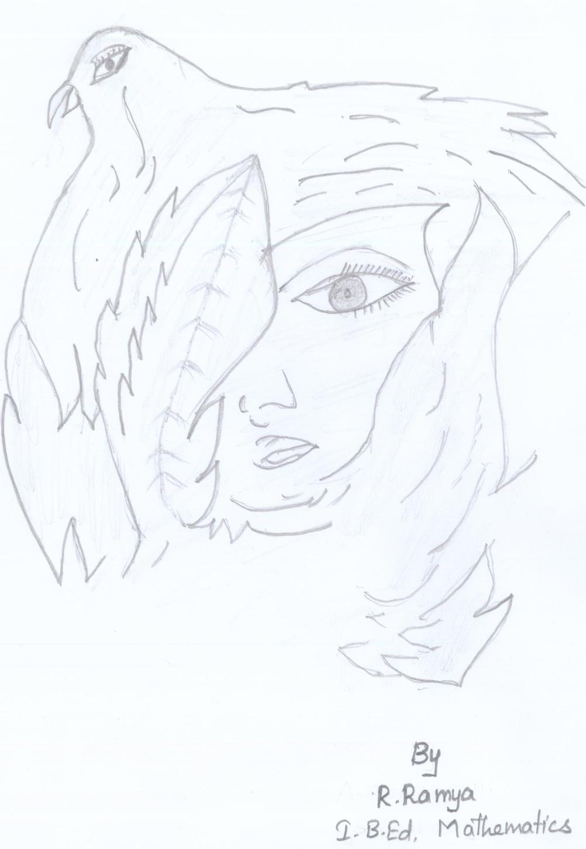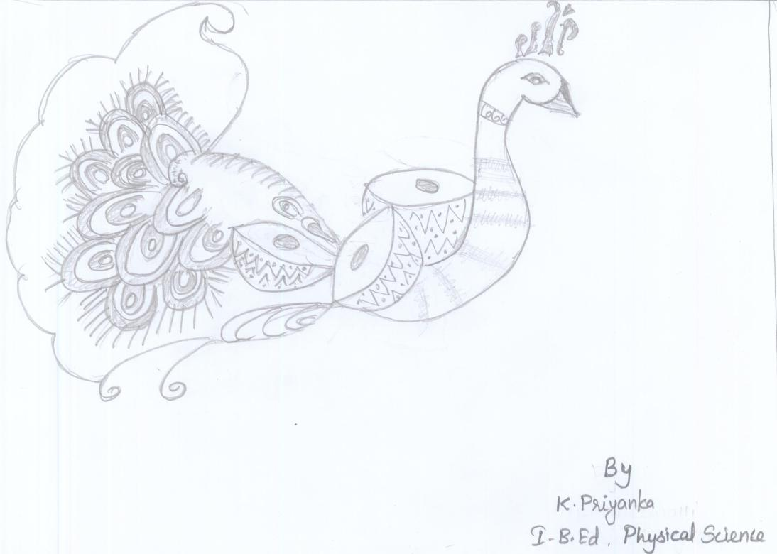
PHOTO GALLERY
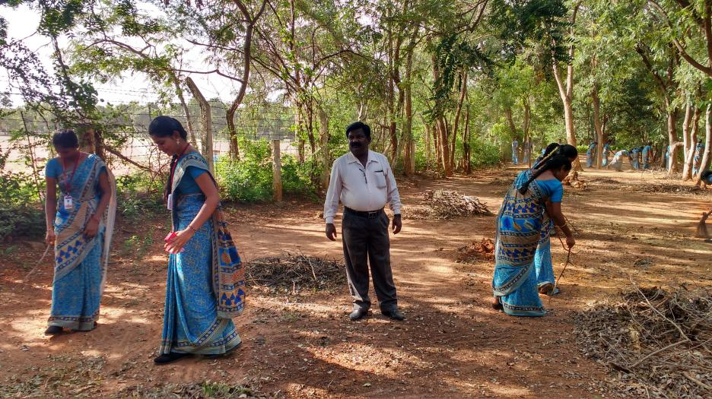
EXTENSION CLEANILINESS SERVICE
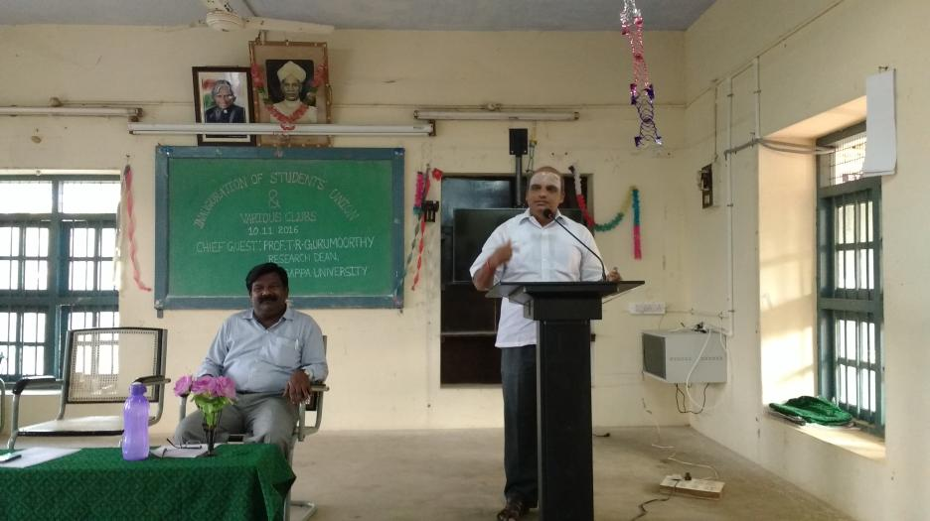
INAUGURAL FUNCTION OF STUDENT'S UNION & VARIOUS CLUBS
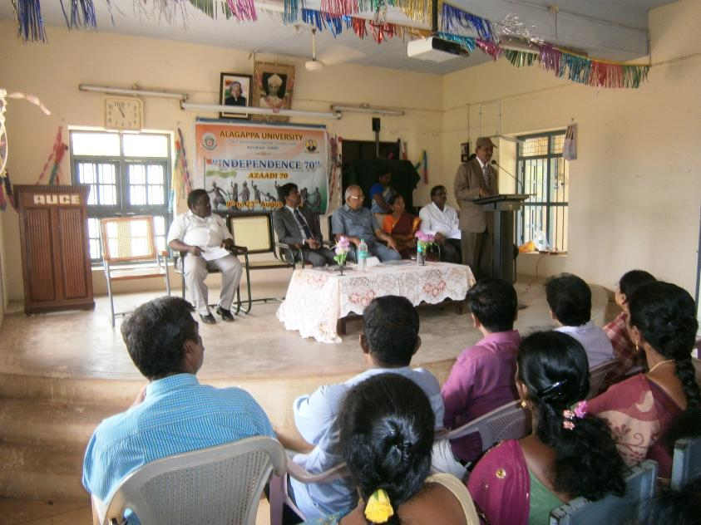
INDEPENDENCE DAY CELEBRATION
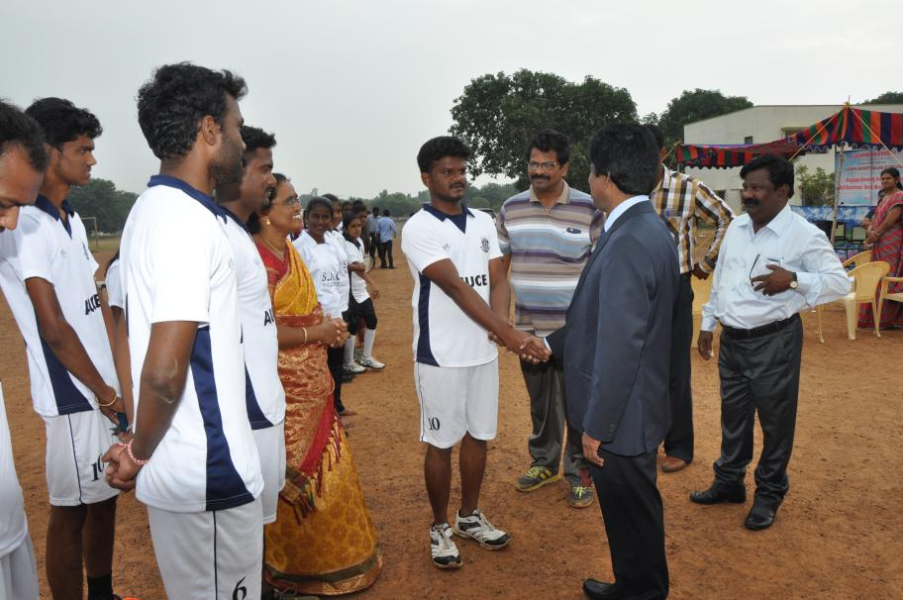
INTER-COLLEGIATE BALL BADMINTON TOURNAMENT
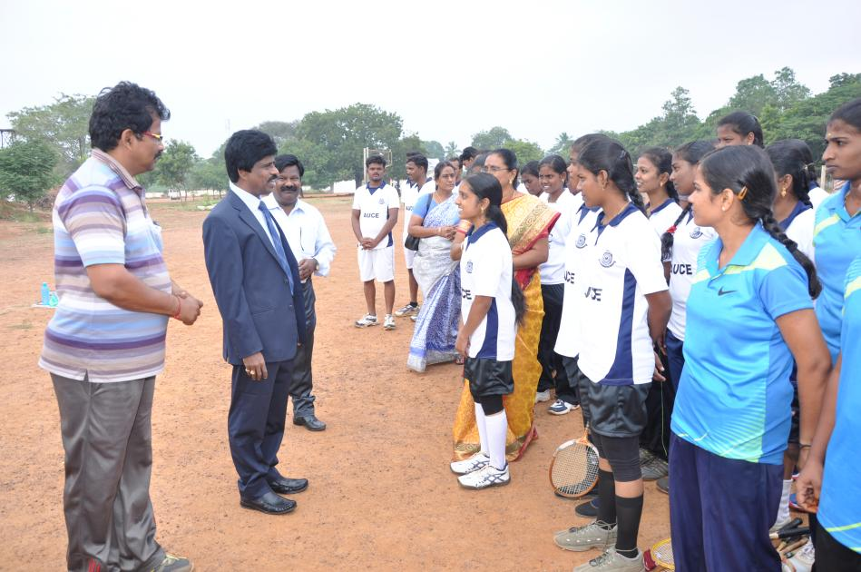
INTER-COLLEGIATE BALL BADMINTON TOURNAMENT
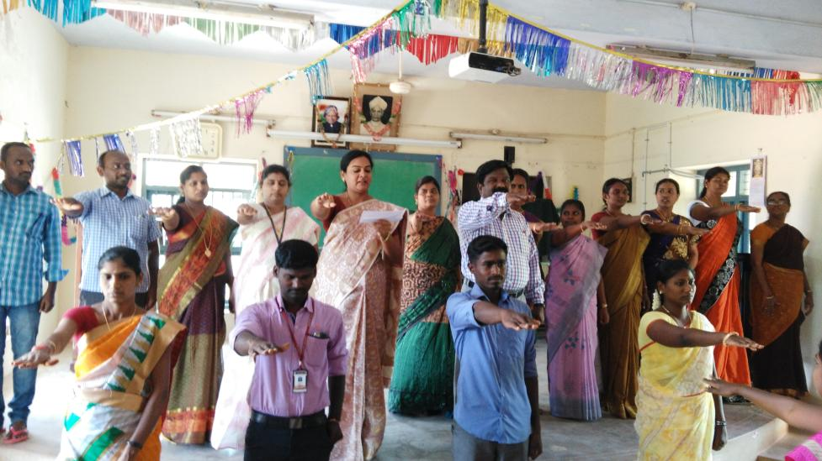
OATH TAKING ON COMMUNAL HARMONY DAY
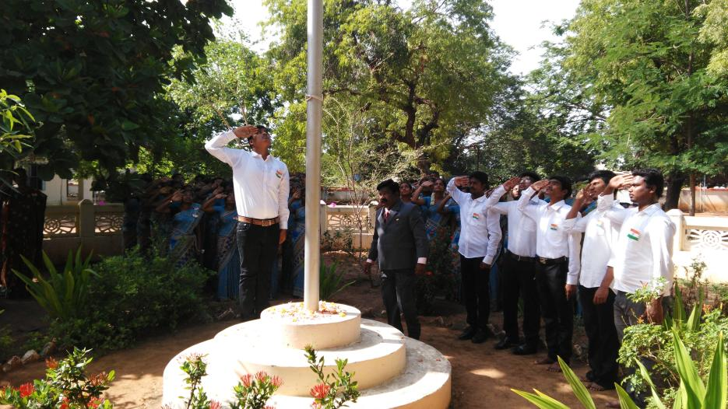
REPUBLIC DAY CELEBRATION
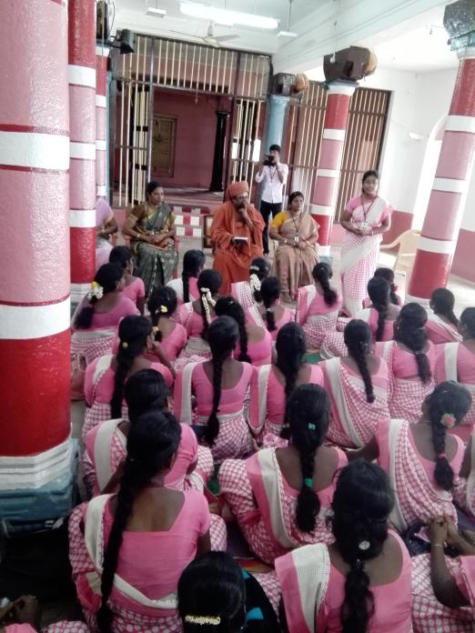
Rural Service of Prospective Teachers (B.Ed. II Year 2017), Kundrakudi Village
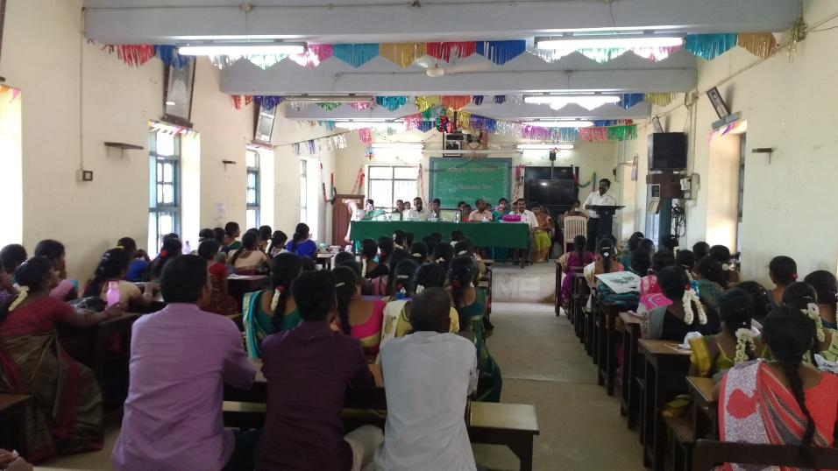
TEACHER'S DAY CELEBRATION

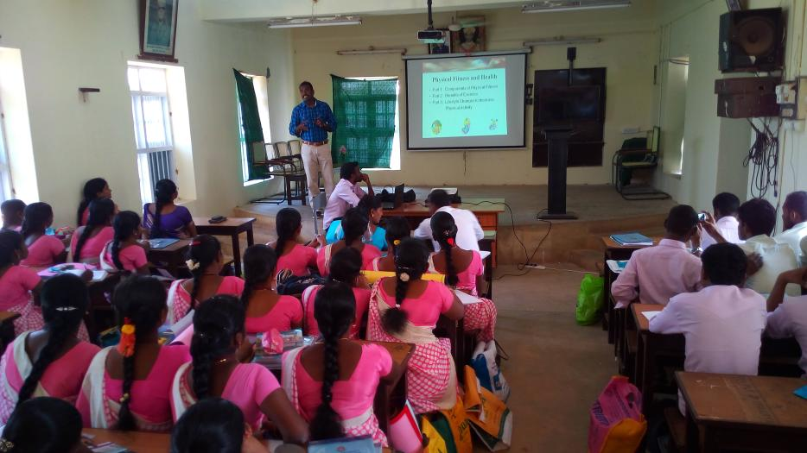
WORKSHOP ON CITIZENSHIP SKILLS

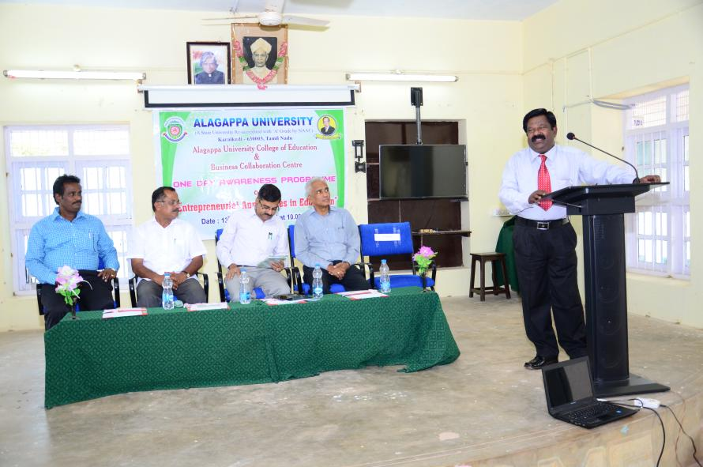
WORKSHOP ON ENTREPRENEURIAL APPROACHES IN EDUCATION
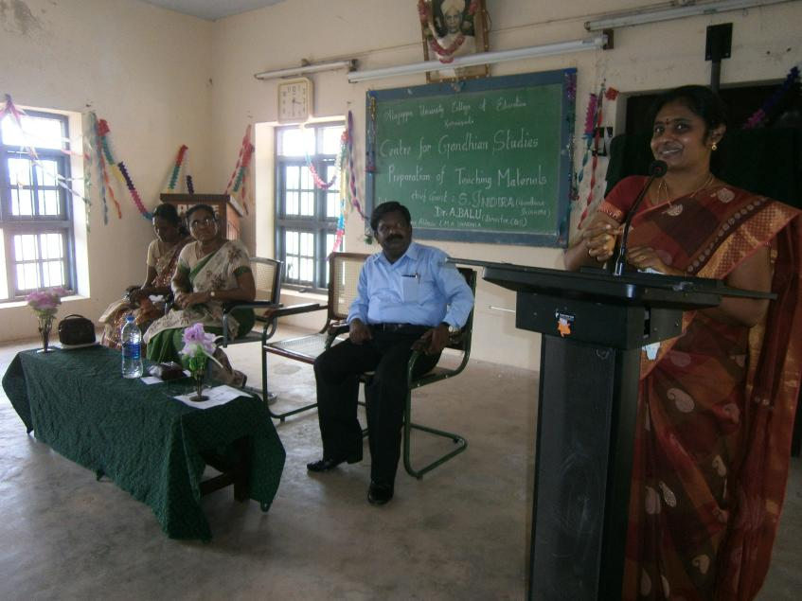
WORKSHOP ON TLM
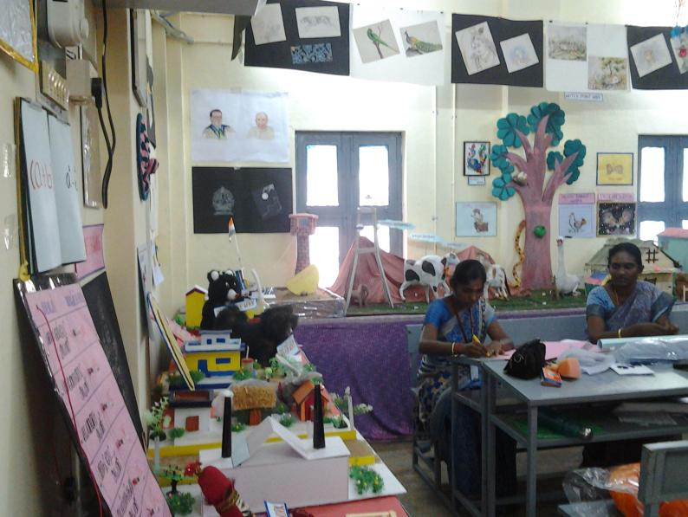
DISPLAY OF TEACHING - LEARNING MATERIALS AND HANDICRAFTS
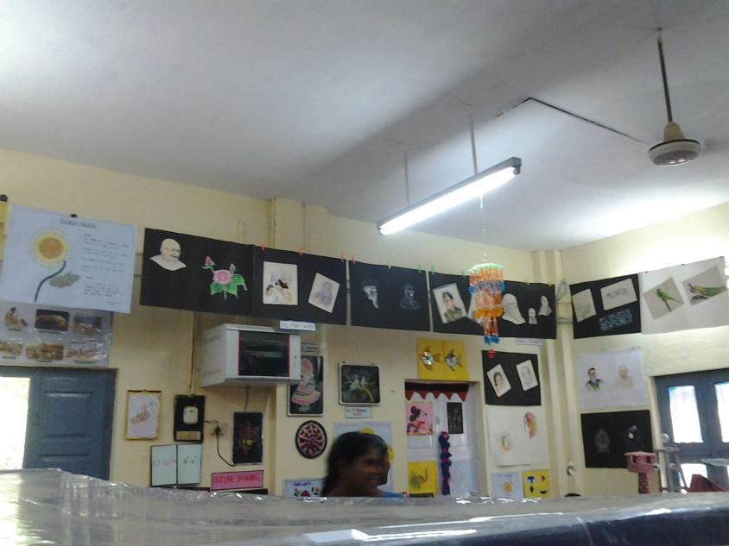
DISPLAY OF TEACHING - LEARNING MATERIALS AND HANDICRAFTS

