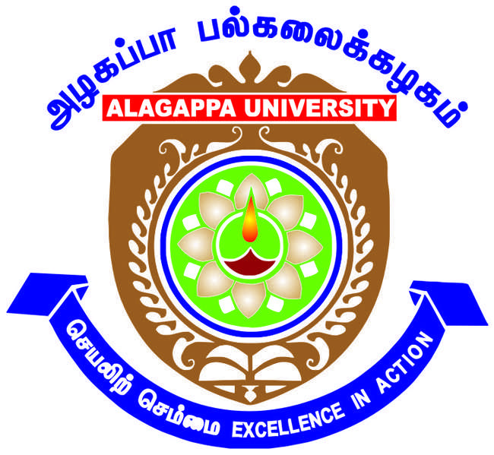

**Career Guidance and Counselling Cell**

**ALAGAPPA UNIVERSITY KARAIKUDI 63003**

|  |  |
| --- | --- |
| **Aim and Purpose** | Informing, Educating, Facilitating and Supporting Career focused student development activities through Seminars and Workshops. |
| Counselling the needy students on personality development related and academic related problems / issues. |
| Extending the Career Guidance Activities to the needy student communities in Schools and Colleges |

|  |  |  |
| --- | --- | --- |
|  | **Designation & Dept./Division/College.** | **Role** |
|  | **Dr. G. Nedumaran**, Associate Professor,  Department of Commerce | Coordinator |
|  | **Dr. G. Ilankumaran**, Assistant Professor, AIM | Coordinator |
| **Members of the Cell** | **Dr. KR. Murugan**, Professor and Head i/c,  Department of Social Work | Advisor |
|  | **Dr. A. Veeraravi**, Associate Professor,  Department of Biotechnology | Member |
|  | **Dr. G. Sivakumar**, Assistant Professor,  Alagappa University College of Education | Member |

Under the General Development Assistance by the UGC during the XI Plan, the Career Guidance and Counselling Cell was established at Alagappa University to help and nurture the students with respect to career and personal development needs.

As indicated by the UGC, Career and Counselling cell helps the students with appropriate guidance to establish linkages with the world of work and locate career opportunities vis-à-vis the realities and job profiles in the context of highly competitive emerging occupational patterns. The gaps in perception about the market demands and individual expectations could be bridged through psychological and confidence building measures. Vocational guidance and campus based interviews have become a common practice. These could be taken care of through the active liaison of the Career and Counselling Cell with the recruiting agencies and HR personnel of reputed firms. The active participation of institutional experts from these gives greater on site experience in search of suitable candidates. In this exercise, the alumni of the University, for positive help, are also involved. They also undertake an affordable training programme to acquaint the students with the high demand market areas and invoke industry-institution linkages.

**OBJECTIVES**

Along with the academic and administrative processes of the University, Career and Counselling Cell is a dispensation of well-informed and interested teachers. It supports the students in the development of soft skills and communication ability to challenge the rigors of competitive tests and on-job-training in add-on or vocational courses. As a purveyor of healthy inter and intra personal relations, it inculcates social values and ability to think independently for carrying out social responsibilities. There is a team of teachers with different subjects and interests and thereby create a homogeneous group to translate this vision and carry out its healthy functions as an institutional imperative.

The guidance and counselling cell in the University is a resource centre of information, guidance and counselling with free accessibility and internet based global connectivity and exchange of information on professional placements.

**FUNCTIONS OF CAREER AND COUNSELLING CELL**

a) To gather information on job avenues and placements in different institutions and concerns related to the courses that the University offers.

b) To analyze information in the local, regional and national contexts to explore it relevance and utility for the students in their placements and on job-training.

c) To organize seminars and guidance workshops for informing students about the emerging professional trends and events, job profiles, leadership roles, entrepreneurship, market needs and risks and implementation of national socio-economic policies and to impart training in soft skills.

d) To promote discipline, healthy outlook and positive attitudes towards for national integration and removal of narrow provincial preferences and prejudices.

The Career Guidance and Counselling Cell is constituted to provide to students community all possible assistance in choosing the appropriate avenues. To enable the students to realize their primary ambition, it has become imperative to counsel and encourage them to set definite goals. The cell provides guidance and training by briefing about various avenues during the time of admission.

* Organizing talks and seminars regarding different job oriented and vocational courses.
* Inviting career counsellors to inform students about job prospects of different• subjects. Conducting aptitude tests, mock interviews and group discussions.
* Arranging personal development programmes.
* Encouraging the students to participate UPSC and TNPSC Examinations
* Organizing career talks and seminars with the help of experts
* Updating the students with latest information on Industry and Economic Trends

**Activities Carried out**

|  |  |  |  |
| --- | --- | --- | --- |
| **Year** | **Description of Activity** | **Date** | **Participants/**  **Beneficiaries** |
| 2017 | Two Day Workshop on Employability Skills | 13/03/2017 to 14/03/2017 | 400 Students of PG Final Year from All the Departments of our University |
| 2016 | Five-day Training Programme on Cambridge English Language Assessment | 05/12/2016 to 10/12/2016 | 50 students |
| 2016 | Mock Test for TNPSC Group -2A (Non- Interview) posts | 10/01/2016 | 165 students |
| 2014 | Career Guidance and Counselling for Rural School Students of VIII and IX std | 03-02-2014 to 13-03-2014 | 1000 students of 10 schools |
| 2014 | Career Guidance Program Series | 12.2.2014 to 27.03.2014 | 800 students of University Departments |
| 2013 | Aptitude Examination Training | 21/01/2013 to 24/01/2013 | 700 students |
| 2012 | Skill Modular Training | October 2nd Week of 2012 | 700 students |
| 2012 | Analytical, Verbal and mathematical ability tests to final years students – Phase III | 27/09/2012 to 29/09/2012 | 700 students |
| 2012 | Empowering Young Leaders Seminar | 29/03/2012 | 180 students |
| 2011 | Careers and Self Leadership Workshop | 20/09/2011 | 250 students |

**PHOTO GALLERY 2016 - 2017**

Two Day Workshop on Employability Skills organized from 13/03/2017 to 14/03/2017

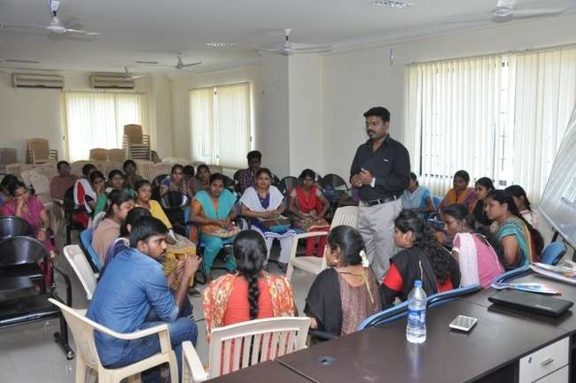

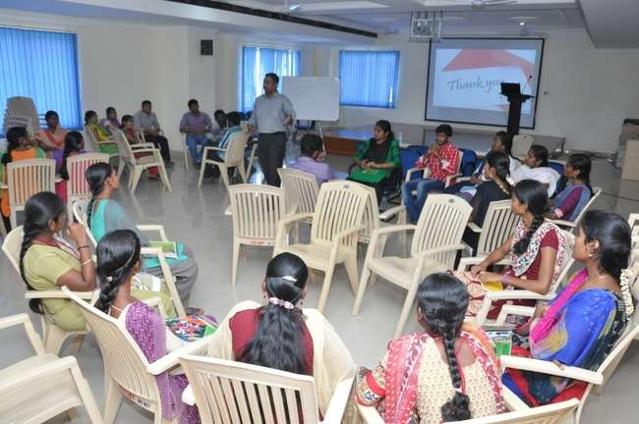

The inaugural function of a Five-day Training Programme on Cambridge English Language Assessment was held on 5.12.16 at Alagappa University under the joint auspices of the Department of English and Career Guidance and Counselling Cell of the University.



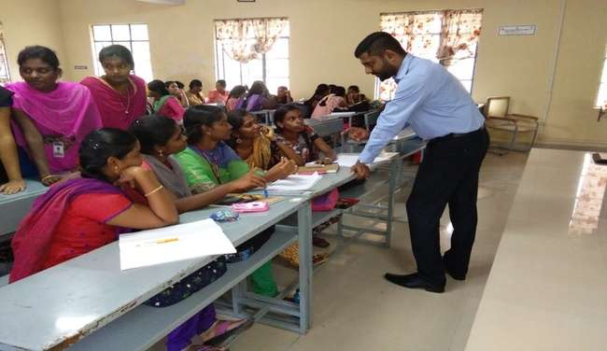

**CAREER GUIDENCE AND COUNSELLING CELL (CG & CC)**

**Report 2015 – 2016**

**(CG & CC**) has conducted a **Mock Test for TNPSC Group -2A (**Non-Interview) **posts** on **10.01.2016** between **10AM to 1PM** in our **College of Education Campus.** This program was conducted in collaboration with **Dr. P. Suresh Kumar, Director, Alagappa University study Circle,** Alagappa University, Karaikudi.The test session was started with the introductory speech by the co-ordinator Dr.G.Paruthimal Kalaignan, Professor, Department of Industrial Chemistry, Alagappa University and Dr. P. Suresh Kumar, Director, Alagappa University study Circle, Alagappa University, Karaikudi. Mock Test question papers were prepared both in Tamil and English. Registration of the Mock Test was started at 9AM on 10. 01.2016. In this Mock Test program, **165 students** have participated from all over Tamilnadu. **19 students have written the Mock Test in English and rest of** **them in Tamil. Number of Men and Women participant were 81 and 84 respectively.** Participants were coming from **12 districts of Tamilnadu**. Higher number of participants from **Sivagangai, that is 104, 23 from Ramnad and 13** **from Madurai.** Total number of participants in district wise was given in **Table.**

After completing the Mock Test at 1 PM, immediately the answers were announced and **corrected the OMR answer sheets** with the help of participants. After the lunch break, once again participants were assembled in a hall at 2PM for **discussion session** to clear the doubts raised by the participants in the mock testquestion paper. The discussion session was over by 5PM on 10.01.2016.

All the participants were happy and appreciate our program. Finally, the Co-Ordinator thanks the Vice Chancellor, Registrar and Finance Officer of our University and the participants for the successful conduct of the Mock Test program.

During the Mock Test, **photographs** have been taken by the Mayil Studio, Karaikudi. I have included some of the important photographs in the report.

**Dr.G.Paruthimal Kalaignan**

**Co-ordinator**

**Career Guidance and Counselling Cell**

**CAREER** **GUIDENCE** **AND COUNSELLNG CELL (CG&CC)**

**Mock Test for TNPSC Group -2A (Non- Interview) posts**

**Date: 10.01.2016 & Venue: College Of Education, Alagappa University, Karaikudi.**

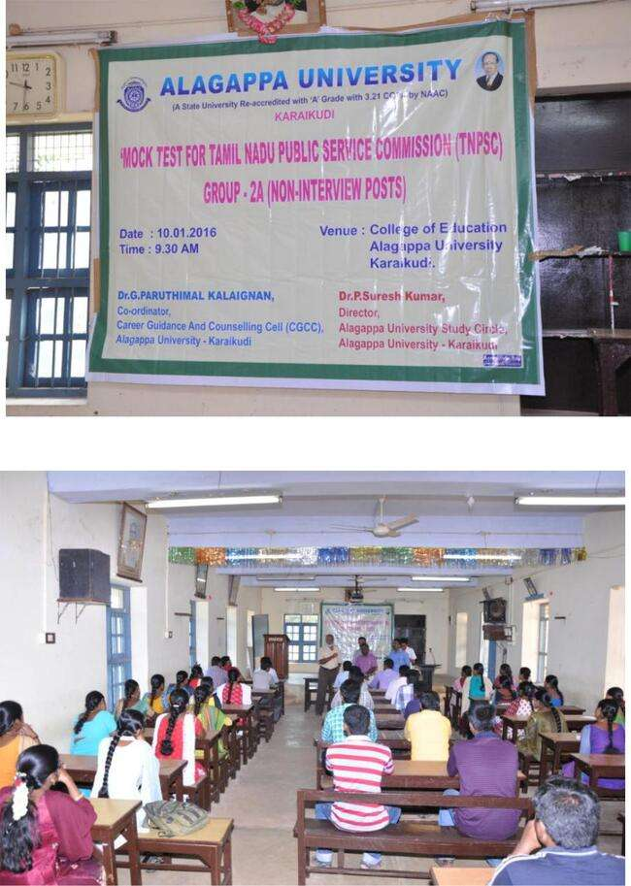

**Career Guidance & Counseling Cell**

**Report for 2013 – 2014**

**Co-ordinator – Dr.H.Gurumallesh Prabhu,**

Professor, Department of Industrial Chemistry

Dr. H. Gurumallesh Prabhu, Co-ordinator of CG&CC conducted a series of lectures for the 20 department students of Alagappa University, Karaikudi under the UGC XII Plan Development Assistance Scheme for the year 2013-2014 from 12.2.2014 to 27.03.2014. Valedictory function was conducted in the last day activity (27.03.2014).

**Details of Programs conducted during 2013-14**

|  |  |  |
| --- | --- | --- |
| **Date** | **Department** | **Expert** |
| 12.02.2014 | Physics | Dr. S. Dhanuskodi, Prof. & Head, Dept. of Physics, Bharathidasan University, Trichy |
| 15.02.2014 | Mathematics | Dr.M.Marudai, Prof.& Head, Dept. of Mathematics, Bharathidasan University, Trichy. |
| 17.02.2014 | Industrial Chemistry | Dr. G. Sethuraman, Professor, Dept. of Chemistry, Gandhigram  Rural Institute, Gandhigram |
| 17.02.2014 | Computer Sci. & Engineering | Dr. P. Shanmugavadivu , Associate Professor , Dept. of Computer, Gandhigram  Rural Institute, Gandhigram |
| 19.02.2014 | Biotechnology | Dr.K.Natarajaseenivasan, Professor & Head, Dept. of Microbiology, Bharathidasan University, Trichy |
| 20.02.2014 | Women’s studies | C.X.Elango, Director, **New-213/Old-**143,Valluvarkottam High Road, Nungambakkam, Chennai -600034 |
| 20.02.2014 | Bank Management | Mr.N.Krishnamoorthy, Visiting faculty, Sri Saradaniketan College for Women, Amaravadipudur |
| 24.02.2014 | AIM | Mr.Jacob, Director, Kriate HR Consultants Pvt Ltd, Ashok Nagar, |
| 24.02.2014 | AIM | Ms.P.Bhamini, Director, Kriate HR Consultants Pvt Ltd, Ashok Nagar,Chennai-83 |
| 25.02.2014 | Animal Health & Management | Dr.S.Pushparaj, Assistant Professor, Dept. of Econometrics, Madurai Kamaraj University, Madurai |
| 28.02.2014 | Dept of Education | Dr. Kokila. S. Thangasamy, Director, Centre for Educational Research, Madurai Kamaraj University, Madurai |
| 05.03.2014 | Corporate Secretaryship | Rn. Senthi Kumaran, JAYCEES National Trainer, 13/1 RTS Illam, Kalanivasal, Karaikudi |
| 05.03.2014 | Corporate Secretaryship | R.R.Ganesan, Career Trainer, 612, Periyar Nagar, Rajagopalapuram Housing Unit, Pudukottai |
| 05.03.2014 | Corporate Secretaryship | S.Alakappan, Career Trainer, No.1, Mena  Veethi, Head Post Office Opp. Pudukottai |
| 08.03.2014 | International Business & Commerce | Mr.D.Rajendran, Managing Director, MRT Chemicals, Karaikudi |
| 12.03.2014 | English & Foreign Languages | Dr. P. Suresh Kumar,  Former Regional Director (Employment)  Employment Office, Tiruchirapalli |
| 14.03.2014 | Economics & Rural Development | Dr. S. Iyyampillai, Senior Professor and Head, Department of Economics  Bharathidasan University, Kajamalai Campus  Mobile: 98424 4883  Tiruchirapalli – 620 024., E-mail: [sipillai@yahoo.com](http://f6mail.rediff.com/prism/writemail?mode=mail_to_individual&email=sipillai@yahoo.com&filename=1394534089.S.26589.31506.H.TkFubmFzYW15IE5hcmF5YW5hbW9vcnRoeQBDQ0QgUHJvZ3JhbW1lIGF0IERFUkQ_.RU.rfs290,rfs290,80,876.f4-235-189.old&folder=Inbox&els=ab5afe966fd51c6e7dca1959b37f4566) |
| 19.03.2014 | Corporate Secretaryship | Mr.Lakshmanan, Karaikudi |
| Mr.Venkatesh, Karaikudi |
| Mr.Sathyanarayanan, Chennai |
| 24.03.2014 | Tamil | Dr. M. Elangovan, Assistant Professor, Department of Tamil, |
| 25.03.2014 | Library & Information Science | Dr. K. Elavazhagan, Librarian & Chief Knowledge Officer, Indian Institute of Management, NIT Campus Trichy |
| 27.03.2014 | Bioelectronics & Biosensors | Dr. V.Ganesh, Scientist, CSIR-Central Electrochemical Research Institute, Karaikudi |
| 27.03.2014 | Industrial Chemistry | Dr.P.Thomas Muthiah, Prof. & Head, Dept. of Chemistry, Bharathidasan University, Tiruchirapalli |
| 27.03.2014 | Valedictory | Dr.P.Thomas Muthiah, Prof. & Head, Dept. of Chemistry, Tiruchirapalli |

**Dr. N. Arunachalam, Professor & Head, Department of Life Long Learning, Alagappa University conducted Career Guidance & Counseling programme for VIII and IX std rural school students from 03.02.2014 to 04.03.2014.**

**Career Guidance & Counseling Cell**

**Report for 2012 – 2013**

**Co-ordinator – Dr. J. Jeyakandan,**

**Professor & Head,**

**Department of Bioinformatics,**

Dr.J.Jeyakandan, Co-ordinator of CG&C conducted the I, II & III phase of carrier guidance (i.e, Analytical, Verbal and mathematical ability tests to final years students). M/S Transtaff Solutions Pvt. Ltd., Chennai, has been assigned to conduct aptitude and soft skills training to the final year students of Alagappa University. Accordingly, the following three phases of events were completed by them.

I Phase – Motivation and orientation to students on 27th -29th September 2012.

II Phase – skill modular training to students during Second / Third week of October 2012.

III Phase – Aptitude Examination to students was conduct from 21st -24th January 2013.

Career Guidance and counseling training programme was conducted for the final year post graduate students from various Departments of Alagappa University during the Village Placement Programme (VPP) which was held from 27.09.2012 to 29.09.2012 at various VPP centers.

**Career Guidance & Counseling Cell**

**Report for 2011 – 2012**

**Co-ordinator – Dr. M. Senthil, Dean, CDC**

UGC sponsored workshop on “CARRERS AND SELF-LEADERSHIP” was organized by Dr. M. Senthil on Tuesday 20th September 2011at 10.30 AM at University Convocation seminar hall. The president of the workshop was Dr. R. Krishnaraj, syndicate member, Alagappa University. The chief guest of the function was Dr. K. S. Chandrasekar, Dean, Faculty of Management, University of Kerala, Kerala. Mr. K. Joesph Zachariah, Director, Vikaasa School, Madurai was delivered the key note address. Dr. M. Selvam, Dean School of Management & Dr. S. Kaliyamoorthy, Dean Student affairs have delivered the felicitation address.

UGC sponsored workshop on “EMPOWERING YOUNG LEADERS” was organized by Dr. M. Senthil on Thursday, 29th March 2012, 10.00AM at AIM conference hall. The president of the workshop was Dr. S. Sudalaimuthu, Vice Chancellor, Alagappa University. Mr. S. Ravindran, Director-HR, Nokia Ltd released the placement brochure of MBA (CS) and delivered the key note address. Dr.V.Manickavasagam, syndicate member felicitated the one day workshop.