Alagappa University Study Circle

Aim and Purpose | With a view to enhance Employability  - Conducting coaching classes for various competitive examinations;  - Conducting mock test/mock interview (need based).  - Career information dissemination.  - Offering guidance and counseling.

Name | Designation & Dept./Division/College. | Status
Faculty | Dr. P. Suresh Kumar | Coordinator
Faculty | Dr. P. Manisankar | Member
Faculty | Dr. A. Padmapriya | Member
Faculty | Dr. N.M. Prabhu | Member
Student Representative | Mr.R.Rajaguru | Members
Student Representative | Mrs.V.Nirmala | Member

Range of Activities | Established and strengthened Study Circle activities at 37 Affiliated Colleges by providing various competitive examination books worth of (Rs. 1, 85,000 /-). For each college (Rs 6540 /-)
 | Alagappa University Study Circle periodically sends Job / Career related information, notifications, model Test papers and other Study Material connected with conducting of free coaching classes every weekend (Saturdays & Sundays).

Activities Carried out
Year | Description of Activity | Date | Participants/  Beneficiaries
2015 | Conducting Mock Interview for Group - 2 | 23.07.2015 | 5
2015 | Face to Face with Achievers  (Tips for IAS Examination)  (Dr. R. Rajaganapathy.,IAS) | 08.08.2015 | 500
2015 | Face to Face with Achievers  (an Experience Sharing)  Mrs. R. Kalpana RBI Group – B officer & Mr. S. Saravanan IRS officer | 26.08.2015 | 450
2015 | Dr. Umayal Ramanathan College for Women visited Alagappa University Study Circle and got the information on “Career opportunities for women”. | 09.09.2015  11.09.2015  16.09.2016 | 150(3 batches of 50 students)
2015 | One day orientation Programme was conducted to the faculty members and students of Affiliated Colleges of Alagappa University.  “On How to start Study Circle and Strengthen the activities at all affiliated colleges”.  Mr.P.Sreedharan IRS., & Mr.G.Balakrishnan oriented the participants | 28.09.2015 | 122
2015 | Out Reach Programme  Dr. P. Suresh Kumar., visited Sethupathy Government Arts College, Ramnad and Interacted with the Final year students regarding career opportunities. | 29.10.2015 | 130
 | Out Reach Programme  Career Guidance programme for Anandha College, Devakkottai Final Year Students. | 27.11.2015 | 133
2016 | Out Reach Programme  Career guidance Programme for final year students of Seetha Lakshmi Achi College for women, Pallathur | 02.02.2016 | 168
2016 | Career guidance programme in two batches was conducted for the college leavers of Alagappa Arts and Science College, Paramakkudi | 03.02.2016 | 135
2016 | Career guidance talk for College Leavers of Sarada Niketan College, Amaravathiputhur | 11.02.2016 | 147
2016 | Two days Career guidance Programme was conducted at Arumugam Pillai Seethaiammal College, Tiruppathur | 16.02.2016  &  18.02.2016 | 220
2016 | Face to Face with  Mr. K. ElamBhagavath., IAS  (How to crack an IAS Examination) | 17.06.2016 | 500
2016 | Interaction with  Mr. R. Balakrishnan., IAS,  Mr. B. Balamurugan.,IRS | 27.08.2016 | 120
2016 | Job World - An Insight  Thassim Beevi Abdul Kader College for Women students visited AUSC | 03.09.2016 &  04.09.2016 | 60
2016 | Career Guidance for 10th & 12 th students at Government Higher secondary School, Ariyakudi | 04.10.2016 | 90
2016 | Pre-Recruitment Orientation for the participants | 07.10.2016 | 25
2016 | Employ-ability skills for College Leavers at Nehru Memorial College, Puthanampatti | 17.10.2016 | 150
2016 | Guest Lecture on "Enhancing Emplotmentskills" conducted by Department of Commerce. | 23.12.2016 | 60
2016 | Career guidance for 10th and 12th students of AVMM School Vilampatti organized by ALUMNI of the school on 24.12.2016. | 24.12.2016 | 110
2017 | All India Radio, Trichy conducted a Live Phone in Programme on "போட்டித் தேர்வுக்கு" through FM 'VASANTHA ALAIPPUGAL' | 21.01.2017
2017 | Vice-Chancellor of Alagappa University Prof.S.Subbiah., and Dr.Alby John Varghese I.A.S., Sub Collector, Devakottai visits Alagappa University Study Circle | 25.01.2017 | 30
2017 | Interacting with Parents & Students of Singai Sithar Ayya College of Arts and Science, A.Thekkur | 07.02.2017 | 50
2017 | How to face Interview?  Interviewing Tips given to Physical Education Students | 10.02.2017 | 65
2017 | Tips for Group – 1 (TNPSC) preliminary recorded at AUSC by Trichy AIR(All India Radio)Staff . | 12.02.2017
2017 | After 10th & 12th What ? Career Guidance | 13.02.2017 | 100
2017 | Seminar Cum Exhibition on Career Guidance at Arumugam Pillai Seethai Ammal College | 15.02.2017 | 75
2017 | Know your University Programme  Exposing the rural youth of affiliated colleges to the facilities available in Alagappa University | 20.02.2017  22.02.2017  23.02.2017  27.02.2017  28.02.2017 | 350
2017 | Board of trustees of TVS visited AUSC for discussion in connection with extending the guidance of counseling activity to rural youth villages adopted under CSR | 21.02.2017 | 7
2017 | After 10th & 12th What ? Career Guidance | 28.02.2017 | 300
2017 | Alagappa University Study Circle activities connected with strengthening affiliated colleges were reported in the Kalki weekly magazine | 05.03.2017 | 1

KNOW YOUR UNIVERSITY:
Exposing the rural youth of affiliated colleges to the facilities available in Alagappa University. In this programme students will come to know of the facilities available in the university and through a general intelligence test candidates will be short listed.
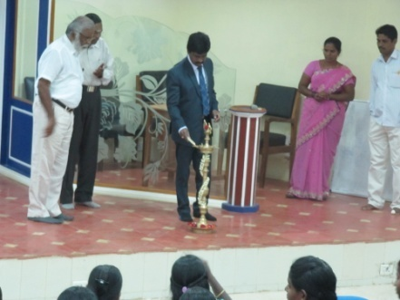
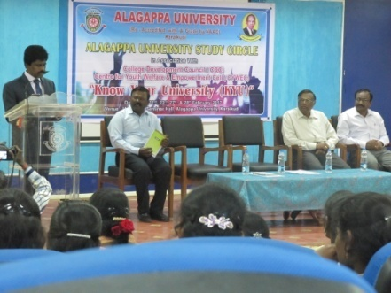

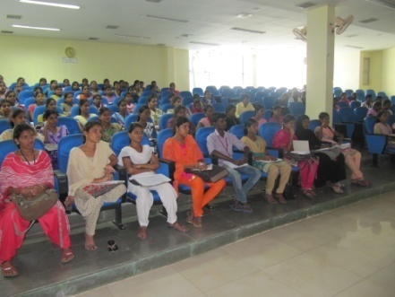
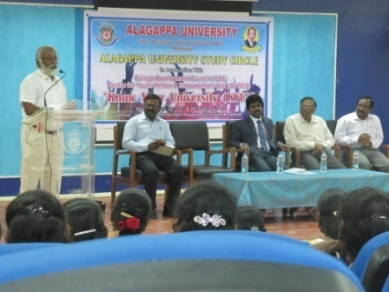

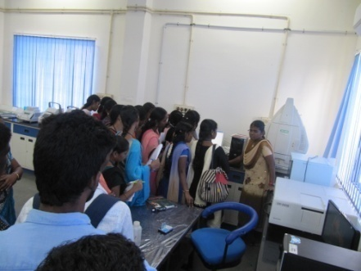
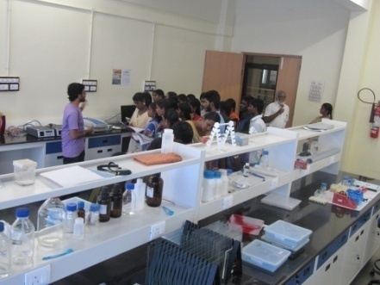
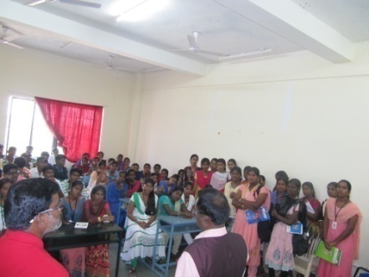
Visiting science block:

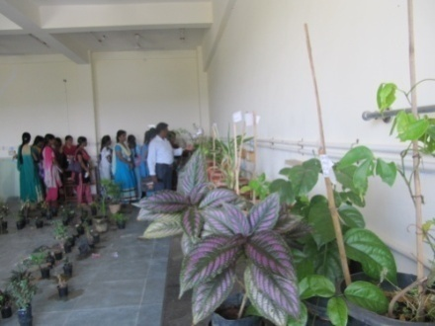
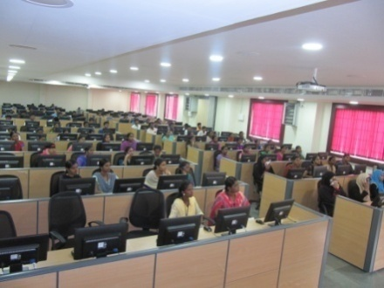

Campus Navigation:
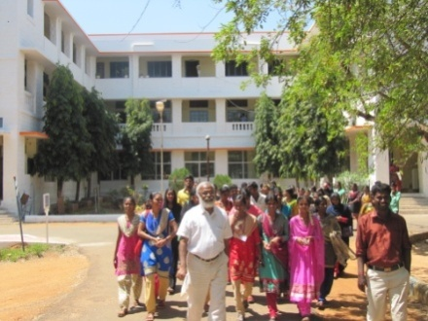
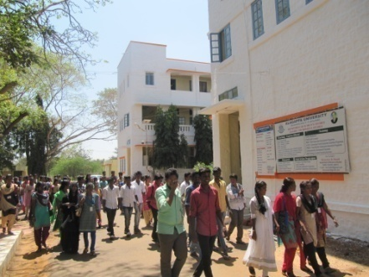
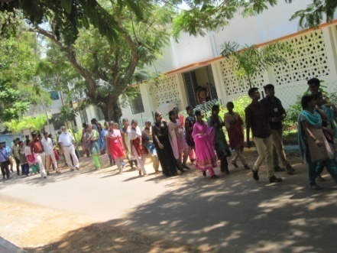
Conducting Test Refreshment
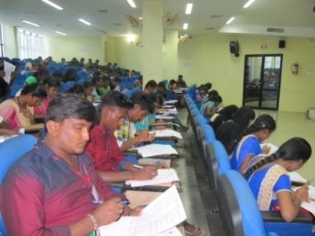
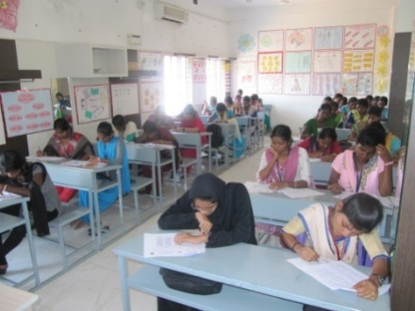
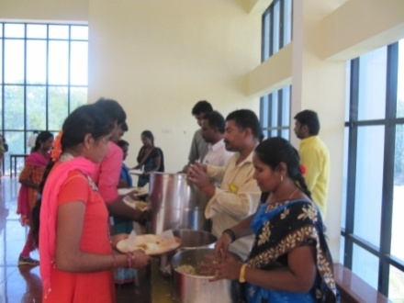
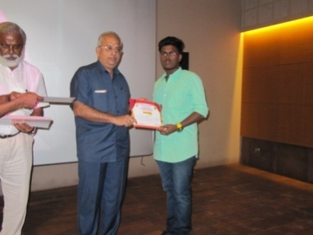
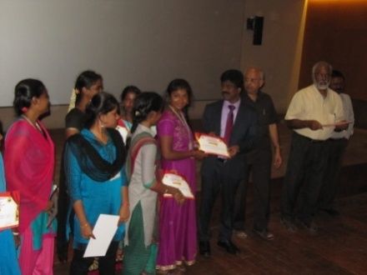
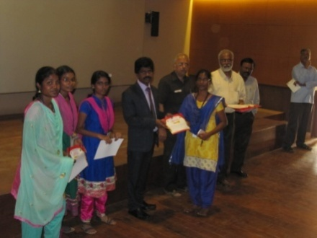
Certificate distribution:

After 10th & 12th What? Career Guidance on 28.02.2017 for 300 students of different schools of Pudukkottai district.
